Chapter 2 - Analytical Framework: Studying Lawfare
Siri Gloppen*

Introduction
This book asks three overarching questions concerning the origins, dynamics and effects of international sexual and reproductive rights lawfare. More specifically: Under which circumstances are cases concerning sexual and reproductive rights brought before international courts? What explains how international courts treat these politicised and morally charged issues? And what are the effects of such internationalised legal mobilisation and adjudication? This chapter, offers an analytical framework for studying international sexual and reproductive rights lawfare – which also serves as a guide to how this volume addresses the three key questions.
The analytical framework presented here aims to unearth patterns of interaction between actors and institutions at national and international level that result in court cases before international courts, and to clarify what influences the actors’ choices and decisions. One central question concerns the impetus for the litigation: to what extent are individual sexual and reproductive rights litigation cases a result of local social and political dynamics, and to what extent are they part of and shaped by broader international movements and campaigns, and if so, what is the nature of this interaction? The framework also seeks to clarify the factors and considerations that influence how international court judges treat the cases, thus contributing to a better understanding of international judges’ behaviour in these morally contested cases – whether they respond to institutional and personal incentives or act in accordance with their norms and beliefs, or put differently, whether it is about who the judges are or the institutional structures they operate within. Finally, the framework provides a lens though which to study effects of these litigation processes and judgments, where central questions in the literature concern the ability of court cases to bring significant social change, and the risks of backlash after court cases on highly contentious issues.
The book addresses these questions from different angles: through case studies of particular litigation processes and the country contexts within which cases arise; from the perspective of the international courts; with a focus on transnational actors; and with the aim to capture potential effects of these internationalised legal battles.
The chapter proceeds as follows. Section 2 conceptualises lawfare in the context of internationalised struggles over sexual and reproductive rights. Section 3 of the chapter outlines a framework for understanding what shapes the decisions made by the key actors involved in such internationalised lawfare processes – litigants, international activists, judges and state authorities. This includes decisions to bring cases, to rule in a particular way, and to comply or not. Section 4 of the chapter outlines a framework for investigating various types of potential effects of such lawfare processes, while Section 5 develops the framework for analysing the dynamic and iterative relationships between key actors as they play out over multiple sites of contestation, before concluding in part six.

Lawfare as an analytical concept
As laid out in Chapter 1, lawfare is understood as the strategic and iterative use of rights, law and litigation as part of a broader struggle between organised social interests to advance highly contested (often morally charged) political and social goals. The allusion to warfare is intended and part of the lawfare concept’s heuristic force, indicating that these are long-standing feuds between ‘armies’ divided by deep, often religious or ideologically defined trenches, extending beyond particular court battles.

2.1 Lawfare as an analytical category
The academic use of the term lawfare dates back to the 1970s, but it is only in the past decade that it has become more common in the scholarly literature and in public debate. The concept is used in different ways, but always with reference to strategies that seek to defeat an enemy by means of rights and law - ‘words rather than swords’. Politically, it is often used in a derogatory way, to denounce what is seen as illegitimate uses of law “the frivolous abuse of domestic or international law to damage and delegitimise an opponent, win a public relations victory, financially cripple an opponent, or tie up the opponent's time”. Accusations of illegitimate lawfare are laid against actors of different kinds, from states’ aggressively using law legal proceedings to advance their interests internationally, and domestically, including “to conquer and control indigenous peoples by the coercive use of legal means” (Comaroff 2001: 306); to civil society activists using international law to advance human rights concerns (for example to delegitimise Israel’s politics towards Palestine); and commercial actors filing SLAPP suits against environmental activists.
However, the lawfare concept is also used in more positive or neutral ways. In the international relations and public international law literature, it denotes strategies “using or misusing law as a substitute for traditional military means to achieve military objectives” (Rabkin 2004) and Charles Dunlap, who first used the term within this field insists on the legitimacy and importance of lawfare in war, “like a tool or weapon that can be used properly in accordance with the higher virtues of the rule of law – or not. It all depends on who is wielding it, how they do it, and why” (Dunlap 2008: 146). Likewise, lawfare is also seen as a potential force for social justice: “sometimes it is a weapon of the weak, turning authority back on itself by commissioning the sanction of the court to make claims for resources, recognition, voice, integrity, sovereignty” (Comaroff and Comaroff 2006: 31). Strategies by which the relatively power-less can make advances by using the law (variably termed “guerrilla lawfare”, “insurgent lawfare” or “lawfare from below”) are seen as particularly important in neoliberal contexts where expanding legal regulations opens spaces for contestation, while many other avenues for social mobilisation are closing through ”downsizing of the state, fragmentation of sovereignty and the formation of socially and economically heterogeneous networks of actors” (Fay 2013:12, see also Comaroff and Comaroff 2009).
Across the various usages, there is considerable overlap with regard to the analytical core of the term. Whether negatively or positively laden, lawfare is understood as the strategic use of rights, law and litigation by actors of different hues as part of a broader ‘war’ between organised interests to advance contested political and social goals. This analytical core can and should be separated from the normative assessment. This separation is central to the current volume, which adopts an empirical and analytical approach, seeking to understand the dynamics and effects of internationalised court-centred lawfare strategies for and against sexual and reproductive rights.
The lawfare concept provides a useful basis for empirical analysis. It paints an intuitive picture of the phenomenon that we want to explore: the long-term contestations between opposing groups, often divided by deep ideological or religious differences that (in part) are fought through law - in courtrooms and assemblies and through legal advocacy. The concept thus provides heuristic force and analytical clarity compared to terms such as legal mobilisation or strategic litigation, firstly, by distinguishing a sub-category of ligation and legal mobilisation processes: these constitute lawfare when used as strategies and tactics in on-going ‘wars’ between organised interests (often, but not necessarily with transnational alliances). Secondly, it broadens the focus with regard to actors, beyond social movements and civil society, to states and actors in government and the political sphere who also engage in the use of law and litigation for strategic purposes. Most importantly, the lawfare concept brings attention to long-term strategies and iterative, reactive patterns between opposing sides, and the interlinkages of lawfare activities across different sites. While building on insights in the social movement literature, of movement-countermovement interaction (Zald and McCarthy 1979; Tilly 1998; Rao 2000; Siegel 2006; Dorf and Tarrow 2014), the lawfare concept foregrounds the role of rights and law in these struggles, across different sites.

2.2 Types of lawfare
In this book, we focus on court-centred and internationalised forms of lawfare, predominantly by civil society actors, in which the contestation involves litigation before international courts or tribunals. These are, however, multi-sited battles, where international litigation forms part of a broader repertoire of lawfare. The broader battles are played out in three main types of sites. In addition to bringing cases before domestic and international courts and tribunals (court-centred lawfare), actors engaged in lawfare frequently use legislative and other norm-setting bodies at national, sub-national and international level to advance their cause (legislative lawfare - including constitutional amendment and regulations). They also commonly engage in less formal legal strategies, including various rights-focused discursive strategies (‘rights talk’) in societal spaces, such as conventional and social media, academia, artistic performances and street protests aiming to bring legal, social or political change (societal lawfare). Often actors have a repertoire of strategies involving a range of sites and modes of lawfare. Civil society actors who are bringing sexual and reproductive right cases to international courts typically also litigate at the national level (prior domestic litigation is normally a precondition for bringing a case to an international body). They also commonly engage in social mobilisation and advocacy for norm-development domestically and sometimes at the international level through transnational activist networks.
The actors engaging in these diverse forms and sites of lawfare also fall in three broad categories. The main focus in this volume is on civil society actors, such as national and transnational social movements, non-governmental organisations, professional associations, corporations and religious groups. However, government actors (elected officials as well as bureaucrats in various positions) also engage in lawfare at national and international level, in and out of court, as do actors in political society, parties and politicians competing for political power. In this volume, government actors are central in the analysis of sexual and reproductive rights lawfare in international criminal courts.
To understand the phenomenon of international sexual and reproductive rights lawfare, we need to comprehend both why these cases are being brought to international courts and treaty bodies, and why the judges decide these politicised and morally charged cases the way they do. In the analytical framework outlined here, the main heuristic device used to unpack and answer these questions is that of the actors’ choice situation. The choice situation has two aspects. The first aspect is the lenses through which the actors see the world and their role in it, including their epistemic frames, beliefs, norms and values. While shaped by how the actors are situated, embedded historical, social, normative and institutional contexts, the lenses are internal and generally taken for granted. The second aspect of the choice situation is the actors’ opportunity structure. The concept, which draws on classical sociology and social movement theory refers to the possibilities for actors to succeed in advancing their aims through various strategies, and the barriers, resources, gains and risks associated with these. While the actors’ lenses shape how they perceive their opportunity structure – and possibilities for changing other actors’ lenses may be part of what they consider as part of their strategies – the actors’ own (internal) lenses are not part of the (external) opportunity structure that defines the strategic field that are considered when choices are made.
The conception of actors’ opportunity structure developed here, and the way it is situated within the broader choice situation, is thus theoretically open with regard to whether actors exercise a “free” choice or primarily respond to and are constrained by social structures in the form of lenses through which they filter the world in the form of institutional or cultural epistemic frames, beliefs, expectations, norms and values.
Explanations of actors’ decisions with reference to their opportunity structure, are usually rational-choice based in that they assume that individuals and groups act according to a ‘logic of consequence’, responding to incentives and acting strategically to further their (collective or individual) aim. For our purposes, this would imply the assumption that activists - and state actors - engage in international litigation if and only if this is expected to better advance their aim than alternative routes (such as political mobilisation); that judges rule in favour of a case only if they expect that it will advance their policy preferences and (individual or institutional) interests; and that decisions regarding how to respond to a court decision are based on similar cost-benefit calculations. We assume that individuals and groups may act according to a logic of consequence by rationally responding to incentives, hence we systematically set out the range of incentives that may weigh in on actors’ decisions in a given context.
However, our conceptualisation of the choice situation also assumes that actors may respond in terms of a ‘logic of appropriateness’, where they seek to do what is right/expected, in response to (societal, institutional and/or professional) norms and values. And that the frames and beliefs through which they approach issues are shaped by historical paths and critical junctures. For example, we might expect an organisation to be more likely to turn to litigation if it is dominated by lawyers who see this as a natural or appropriate form of action, and the staff composition is in turn likely to be a product of the organisation’s origin and history. The analytical framework thus seeks to accommodate the criticisms that different forms of institutionalism offer to rational-choice based explanations, namely that actors (also) are moved by beliefs, norms and values. Such theoretical openness is important since it not only enables a richer analysis of what influences actors’ decisions in a given situation, but also allows for an analysis of which of the theoretical perspectives offered in the literature that holds more explanatory value.
We would assume the logic of appropriateness, and in particular the force of institutional and professional norms to be particularly salient for actors who are firmly institutionally embedded, as judges are when they decide cases. When trying to understand why international court judges accept sexual and reproductive rights cases and decide them the way they do, it is thus relevant to consider the legal culture of the institution, and the judges’ professional norms regarding appropriate legal reasoning and what it is to be a good judge (which is particularly complex for international courts, given their geographically diverse composition). This, along with the judges privately held beliefs and norms is relevant both for their ‘prior’ opinion on what is the right outcome of the case, and for how they relate to their opportunity structure, as illustrated in Figure 2 further below.
The analytical framework thus aims to disentangle and clarify the factors that are relevant and likely to weigh in when activists (or state actors) decide to take a case to an international court and how it should be framed; when judges decide to accept a case and how to rule; and that influence reactions to a ruling by affected actors (within government, in the political sphere and in civil society).
In decisions to engage in international lawfare, important considerations for litigants are assumptions concerning the reactions and future actions of others – the opposing side, the judges, political allies. This forms part of their opportunity structure. Similarly, for international judges deciding the cases, potential (re)actions, for example from other judges or important governments may form part of their opportunity structure. Inversely, an international court ruling may significantly change the opportunity structure of a range of actors who were not even part of the case. It can open up – or close – possibilities for new court actions or for advocacy domestically or internationally. This dynamic and interlinked nature of actors’ opportunity structures is particularly pronounced in lawfare processes, that by definition are iterative, long-term struggles, where organised interests fight over social change. Here questions regarding how their opponents – and allies – will be affected by the international legal case, what their response will be, and how this will affect subsequent battles and the longer-term objective are often centre stage. When analysing these processes, the dynamics between actors both in terms of real and anticipated reactions, are thus important to capture.
We are particularly interested in understanding what we may call legal-political trigger-mechanisms. These are interaction patterns between legal, political and civil society actors and institutions that occur as part of, or in response to litigation processes. They can take the form of supporting or opposing activism or litigation; enactment of new legislation or constitutional provisions; change of policy, resistance to, or support for implementation; change in public opinion etc. International litigation is often a response to various forms of lawfare by actors opposed to the cause, or by allies – and it may also itself trigger new lawfare at domestic or international level. This could be new cases before domestic and international courts, but it might also be confined to other sites and typically include engagement in international norm setting processes, domestic constitution-making and legislation, and social mobilisation.
Trigger-effects can also be transnational. An internationalised litigation process can trigger lawfare responses, for example in the form of constitutional change, in countries other than that from which the litigation originated. An example of what appears to be cross-boundary trigger-effects related to sexual and reproductive rights lawfare, is the increasingly common enactment of constitutional provisions stating that ‘marriage is between a man and a woman’, or that ‘life begins at the moment of conception’, that seem to be a response to what conservative religious actors perceive as disturbing international trends towards liberalisation (Lemaitre 2012; Kaoma 2012). Litigation may also be inspired or incentivised by actors and agendas beyond the country in which the case originates.
A better understanding of these trigger-mechanisms – how international litigation and judges’ decisions trigger supportive or adverse responses in other actors – are central to understanding why and when sexual and reproductive rights cases are brought to international courts (and are litigated in the first place); and to understand why international courts deal with these politicised and morally charged cases the way they do; and, not least to understand why these litigation processes (don’t) produce particular effects, as government and private actors respond to and (fail to) comply with the decisions.

Actors and choices

3.1 Analysing the litigants
We now take a closer look at how the central actors can be analysed through the lens of this analytical framework. Some of the chapters in this volume are cases studies of a particular internationalised litigation processes or processes arising within a country (Peru, Costa Rica, Austria, Uganda). They aim to understand the input side, the dynamics that lead to the cases being litigated at international level at a particular time and in a specific way, as well as the outcomes and effects of the litigation process.
In studying what drives and shapes the litigation process (its domestic origins as well as the international court case), the case studies aim to shed light on to what extent the dynamics are mainly what we may call legalistic mimicry, that is, triggered or inspired by foreign actors, or rather should be understood in terms of local path dependencies and actors rooted in local religious or other traditions – or a combination, where strategic actors at national and international level seek to maximise potential gains within existing domestic and transnational political and legal opportunity structures.
Entering the analytical framework from this perspective, the central puzzle is why the pro/anti sexual or reproductive rights activists choose internationalised litigation, either as their main strategy or to complement other forms of activism, and why they chose a specific focus. To answer this, the analysis firstly needs to uncover what in fact happened. It also needs to probe the motivation of the activists: what is their overarching pro/anti-sexual or reproductive rights aim and (how) has this changed over time? Have domestic and/or international allies contributed towards shaping or advancing this agenda, and/or the use of litigation strategies to advance it?
In light of the competing hypotheses about the reasons for the spread of international sexual and reproductive rights litigation, the nature of international ties is particularly important to explore. International allies may influence activists’ motivation as well as their opportunity structure. Key questions to explore in this part of the analysis are thus to what extent the motivation or ability to pursue sexual or reproductive right litigation was influenced by international links (whether with Catholic or Evangelical pro-life networks; the Centre for Reproductive Rights or other pro sexual and reproductive rights organisations; or with academic networks, donors etc.), including to what extent financial or professional resources have been made available.
The analysis also needs to investigate how the actors perceive their opportunity structure, including what they are up against, who their allies are and which resources they have to pursue different avenues. Given that the decision to pursue international litigation in most cases is only one part of a larger ‘war’ the iterative and dynamic nature of the process is important to capture: what was the litigation a response to; how did it relate to earlier ‘battles’? What were the short-term aims of the case, and how do these relate to long-term goals? Was the case envisioned as a stepping stone in a jurisprudential strategy, or a reactive measure to prevent a harmful enemy strategy, or mainly a strategy to gain attention, credibility or allies?
Figure 1. Litigants’ choice situation and opportunity structure
Logic of appropriateness Logic of consequence
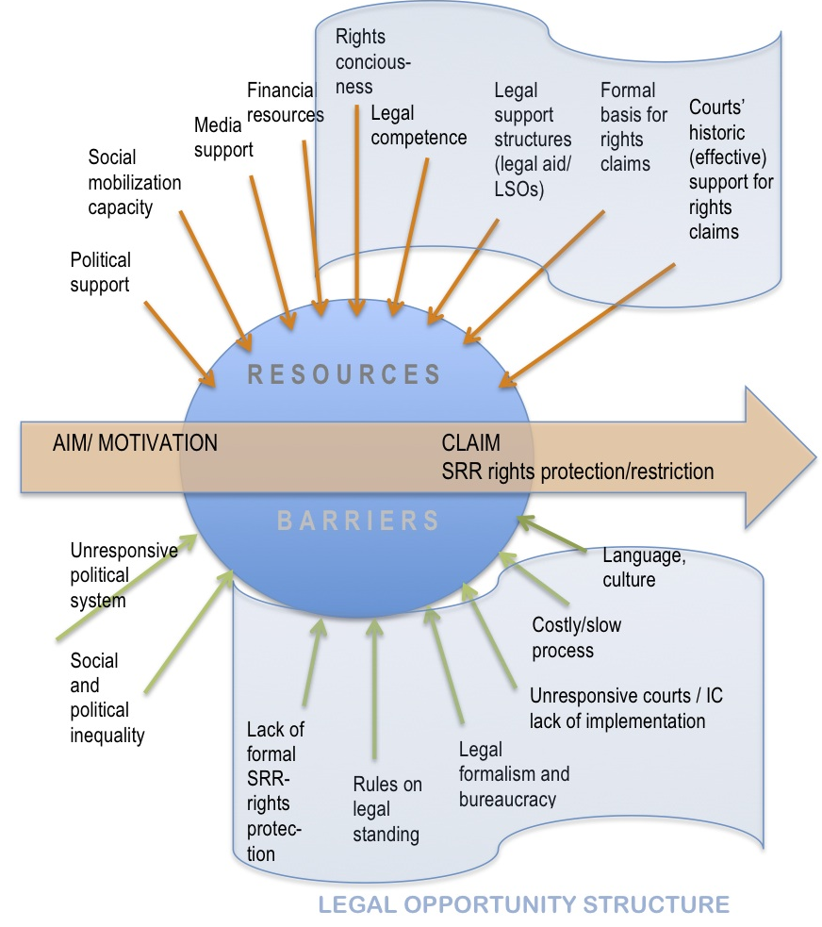
This choice situation, where litigants’ decision to take a case to an international court is made, is illustrated In Figure 1 above. It illustrates how actors’ decisions are conditioned by their motivations and goals, that is, what they aim to achieve in the immediate as well as the long term - as well as by what they see as possible and acceptable avenues of action open to them and which of these strategies that they consider most likely to advance their goals.
To determine actors’ “real” motivations and goals, beyond what is expressed in their court papers or other statements, is fraught with uncertainty, particularly where these are collective actors with potentially diverging individual, institutional and political motives. And it becomes particularly difficult – but also important – to assess in situations of lawfare where each decision is likely to be informed by long-term strategies. It is also important is to keep in mind that litigants’ decisions to take a case to an international court may not only be motivated by a desire to do the right thing, or advance their policy goal – in this case to advance or limit sexual and reproductive rights. It may also be (partially or mainly) motivated by personal ambitions or by institutional concerns, such as a desire to secure finance, prestige, or a protective shield for the organisation through international visibility.
Potential litigants’ opportunity structure is in part defined by factors perceived as barriers or obstacles to achieving their aims through various available routes. This can be related to the social and cultural conditions they operate in (the social opportunity structure) where for example adverse religious or social norms, or entrenched prejudices may make it hard to advance their cause through mobilising social and political support. Barriers can also be related to the political conditions in which they operate (the political opportunity structure) which may be such that it is unlikely to advance the cause though political forms of mobilisation. And there may be barriers arising from the nature of the legal system that may discourage legal mobilisation. The legal opportunity structure may be adverse due to formal and economic barriers to access; poor legal foundations for their claims; ideologically adverse judges, courts that lack independence, or that have little authority so that their rulings are unlikely to be respected and have traction on the ground.
On the other hand, the opportunity structure is defined by the resources that activists/potential litigants have access to. This can be financial resources, political connections, allies among opinion leaders, in the media, or access to legal or other relevant expertise that might enable them to overcome the (perceived) barriers and that thus make the social, the political, and/or the legal opportunity structure appear more favourable. These may be resources that actors have, or resources that they gain access to though domestic or transnational alliances.
The combination, at a given point in time, of barriers and available resources will constitute the overall opportunity structure for advancing a particular goal through international litigation as opposed to, or in addition to other available strategies. Actors’ strategies and tactics are thus formed in the interface between their motivation and their opportunity structure. As Langford, Vibe and Kirkebø discuss in their chapter, we might speak of a constructed opportunity structure. The opportunity structure does not determine an actors’ choice, but represents the sum of conditions and circumstances in which they make decisions. Clarifying the opportunity structure of sexual and reproductive rights activists of different ideological convictions thus provide insights into the circumstances under which they are likely to take their case to international courts and how the international litigation plays into their broader struggle.
To get at these issues in a concrete context will typically involve a combination of key informant interviews, critical reading of existing literature, and analysis (qualitative and/or quantitative/machine assisted) of court documents, other archival material and media reports. Box 1 presents some questions that might serve as a starting point for an inquiry to assess litigants’ motivation, opportunity structure and broader choice situation.

3.2 Analysing transnational actors
Box 1: Probing litigants’ motivation & opportunity structure for sexual & reproductive rights
- What is the history and trajectory of activism and (domestic/international) litigation in this context?
- How are these rights issues reflected in the society (religion, social norms, sentiments)?
- Who are the central actors driving the pro/anti movements (norm-entrepreneurs)? Are the litigators among them, or if not, is there a relation?
- What is the configuration of pro/anti forces in the country? What are the alliances and international linkages of opposing groups?
- How is this reflected in the political landscape? Are there political parties/public actors (including within bureaucracy) engaged in pro/anti repertoires?
- How are the issues reflected in the media? Do the litigators (or their opponents) have allies in the media? Does this change over time?
- What are the alternatives to litigation? What scope do activists perceive for advancing their aims through political mobilization/advocacy?
- What is the perceived potential for litigation to succeed (legal opportunity structure)?
- What is (or was at time of going to court) the activists’ perception of the domestic legal system and the possibilities for using this to advance their cause? Has this changed over time, and if so how and why?
- What is (or was at time of initiating international litigation) the perception of international courts and the possibilities for using internationalized litigation to advance the cause? What were their considerations when placing the case before the (specific) international court? Has this changed over time, and if so why?
- What role does/did litigation – and internationalized litigation – play within the total strategy to advance their pro/anti-sexual and reproductive rights aims?
When seeking to understand the significance international factors and actors for these international court cases and their domestic precursors, perspectives from the individual countries from which international litigation arise, are useful, but can only give a partial picture. This volume thus complements country case studies with an analysis directly focusing on the transnational actors and their role, not only for litigation processes that end up in domestic and international courts, but also for norm-setting in the field of sexual and reproductive rights. Transnational actors may also influence the functioning of international courts and the effects of international court rulings. Transnational actors come in different forms, but in this context the main emphasis is on transnational activist network, both on the pro- and anti-sexual and reproductive rights side.
This part of the analytical framework aims to clarify who the central international actors in the sexual and reproductive rights field are; the relationship between them; what their roles and relative importance are in these processes; and why they make the strategic choices that they do. This includes the role of various transitional actors in litigation processes and in norm development; the influence of (particular) transnational actors on (specific) international courts; as well as their role in shaping the effects of the international court decisions – including in influencing reactions to, implementation, and follow up of international court judgments. Again, the nature of the linkages between transnational and domestic activists is a core question. This part of the book complements the cases studies in bringing out and probing different facets of the relationship between domestic and international actors in these litigation processes to understand under which conditions (if at all) international activists are the main drivers or shapers of international sexual and reproductive rights lawfare. The ambition is to generate synergies between the studies in ways that enhance the opportunities for understanding the domestic-transnational relationships.
There are competing hypotheses in the literature reading the nature of the relationship between domestic and transnational actors. As outlined earlier, a central issue is the extent to which western/US actors influence battles around sexual and reproductive rights in other parts of the world. The analysis of transnational actors can help us understand linkages between internationalised sexual and reproductive rights legal battles that arise in different countries around different issues and that end up before different international courts. Key questions that are explored include:
Role of transnational actors in norm-development: The past decades have seen a very significant development of international norms relating to sexual and reproductive rights, and one of the aims of the study is to get a better sense of the role of various transnational actors the normative development in order to shed light on who have been the main ‘norm entrepreneurs’, and the nature of their influence. A useful tool is to identify key sites (locations in time and place) for norm development in different sexual and reproductive rights-fields, and seek to map patterns of interaction around these processes. To track the drafters of central documents may also provide useful insights
Relationship between transnational actors and international courts: We are also interested in whether and how transnational actors seek to directly influence international courts. This may happen in different ways. It could for example be through lobbying to influencing the selection of international court judges or commissioners; and though providing information and training for international court personnel.
Role of transnational actors in shaping effects of international court judgments: Transnational actors may also have a significant role in relation to the impact of the international court judgments. This may take different forms, including spreading (and shaping) information about the international court decisions to activist in different countries and at different level; to judges; and to the general public, collaborating with local activists to use the judgment to create awareness and momentum for their cause. They may also aid domestic activists in follow-up litigation and/or out-of-court advocacy to secure – or prevent - implementation of the international court decision.
Box 2 indicates questions that can help shed light on these dynamics. Again, these issues can be investigated through a variety of methods but will typically benefit from a combination of key informant interviews and (qualitative and/or quantitative/machine assisted) analysis of court documents, other archival material and media reports.
Box 2: Tentative interview-guide for transnational actors
- To what extent are TAs involved in internationalized sexual and reproductive rights litigation?
  - Which TAs are involved? Which (types of) cases are they involved in? Which countries/regions do they stem from? What is their ideological/religious character?
  - When did they engage in internationalized litigation? What motivated this turn? Are these TAs also involved in domestic litigation in their home country and/or in other countries?
- What is the nature of the TAs involvement?
  - Are they involved in the initial decision to litigate domestically? And international court (and, if so which one)? Are they involved in the choice of cases/framing?
  - Are they involved in out-of-court-mobilization? What type of resources do they provide (financial support; legal expertise; networks; ideological/moral support)
- Why do TAs decide to engage in internationalised sexual and reproductive rights litigation – and why in the specific cases?
  - Here the analysis should follow the strategy outlined in Box 1 above.
  - Analysing the judges
Why do international judges rule the way they do in sexual and reproductive rights cases? Are they doing what they understand the law to require? And, if so, what shapes their understanding of the law? Or are they acting strategically? And if so, which public, institutional and/or private interests are they aiming to advance?
There are different hypotheses regarding what decides how judges rule. Rational choice approaches see this in terms of judges’ individual and collective preferences and interests, and (their perceptions of) what they can get away with given the political context; historical institutionalism may give pre-eminence to the legal culture and path dependency of a particular institution and its related epistemic legal community; while the new institutionalism literature on judicial behaviour and -independence, suggest that judges are more assertive when they are more secure individually and as an institution and if there are like-minded colleagues on the bench. We may thus expect tribunals to be less likely to assert themselves on controversial sexual and reproductive rights cases if the judges’ home states have a strong say in appointments (particularly if this result in judges mirroring cultural and ideological divisions); if tenure and/or finances are poorly secured; if the legal bases for their decisions weak, ambiguous or contested; and in the absence of significant supportive constituencies.
Our analytical framework is again open with regard to which factors have most explanatory force. It acknowledges that judges actions may be motivated by a desire to ‘do the right thing’, be a good judge and rule in accordance with their best understanding of the law – and that these beliefs in turn are shaped by the institutions within which the judges are embedded, both the judicial context from which they were appointed and that of the international court. But the framework also recognises the empirical literature on judicial behaviour, which shows that judges’ motivation, when deciding cases, is also shaped by their private ideologies and policy preferences, and that they, like other actors are motivated by factors related to their personal lives, such as job satisfaction and career prospects (Epstein and Knight 2013). There is also an expanding literature on international courts, that highlight their transnational networks and epistemic communities as well as their ties to their home countries (see for example Voeten 2015, Langford & Behn 2018).
Thus, in analysing their decisions we should, in addition to seeking to clarify the intrinsic motivation of international court judges, also consider the opportunity structure they face which makes up the range of concerns that they are likely to, consciously or unconsciously consider when they decide cases on sexual and reproductive rights. These are factors that may serve as barriers to making what they see at the right ruling, or resources that they can draw on in this regard. While opportunity structures, as developed within the context of social movement theory is generally used to refer to activists’ strategic choices, we here also apply it as a heuristic tool to clarify judges’ concerns as they make their decision. Similarly to what was discussed in relation to the litigants bringing the cases, these concerns may be divided into three distinct sets of factors: social, political and legal opportunity structures.
The legal opportunity structure within which international court judges operate is influenced firstly, by the rules regarding their powers and competencies and the legal norms at their disposal in relation to the case before them. This includes among other the clarity of the international courts’ jurisdiction over the case; the clarity of the basis in law for the issues in question (international legal norms, own prior decisions, case law from other international courts and domestic courts). It also includes meta-norms such as institutional/professional norms regarding the appropriateness of deciding these cases, which is relate to their interpretative theory; conception of separation of power and what belongs in their legal domain etc.; and it includes strategic considerations such as the likelihood of the ruling being accepted by the relevant domestic courts, and by other international courts. Whether the judges have relevant legal expertise, and the strength of the litigant’s voice in the argument brought before them is also relevant for their legal opportunity structure in the particular case. Finally, the practical, intellectual and financial resources at the judges’ disposal influence the extent to which the court has the competence and resources to research these cases.
The international judges’ political opportunity structure is shaped by political context in which they operate (see for example Ginsburg 2014). Considerations arising from this include: what are the chances of having the judgment accepted and complied with? What are the implications for the court’s authority, legitimacy, and political capital? Are there risks that a judgment may result in direct sanctions against the institution or against individual judges? How secure is the court’s funding? Can they risk being financially punished if they adjduciate substantively on politicised sexual and reproductive rights issues?
Individual judges’ vulnerability to pressure is affected by their terms and conditions of tenure, but also by their likely and desired future career paths, and whether either can be decisively influenced by political authorities who may be offended by the decision. The international courts institutional vulnerability is influenced among other by their security of funding, and to what extent their mandate and jurisdiction is protected. History, or past experience is of particular relevance here: have similar cases previously lead to politicisation of the international court? And have judgments in such cases been complied with – or been met with repercussions? Studies of judicial behaviour on international courts, have paid particular attention to the situatedness of international judges in relation to their home country, both in conditioning their beliefs and norms, and in terms of strategic incentives, but also the role of transnational networks, intra-court dialogues and legal epistemic communities (Voeten 2014; Noellkamper 2014).
Judge’s political vulnerability – and hence their ability to act independently in making the decision they deem to be right – is also related to their social support. This is among other related to whether the court has significant allies or protective constituencies to rely on for support and recognition, generally, and on the particular issue. An important question is to whom, if any, the international court can turn for support should the judges’ independence be threatened. Would there be protests and effective sanctions from intergovernmental bodies, political actors in member countries, civil society, or the public? Who, if any are likely to support the judges if they are ‘punished’ in the context of a particular sexual or reproductive rights case? A related question concerns the search for professional and social recognition, Who are the ‘relevant others’ that the international court judges seek recognition from - and what is their stand on the issues in question? This might be colleagues in judicial forums; a community of legal scholars; the state parties to the treaty that they base their work on; or transnational activist groups working on the issues. Indications may be who they cite in their judgements, where they give public lectures, and with whom they regularly interact.
As illustrated in Figure 2, each of these sets of questions include factors that may push international court judges to decide against their original conviction or motivation (these ‘barriers’ are illustrated by the arrows from below) as well as factors that may support decisions in accordance with it (‘resources’, illustrated by the arrows from above). What constitutes resources and barriers in a case and for a particular judge or court will be relative to the case and their preferred outcome.

Figure 2: International court judges’ opportunity structure
Logic of appropriateness Logic of consequence
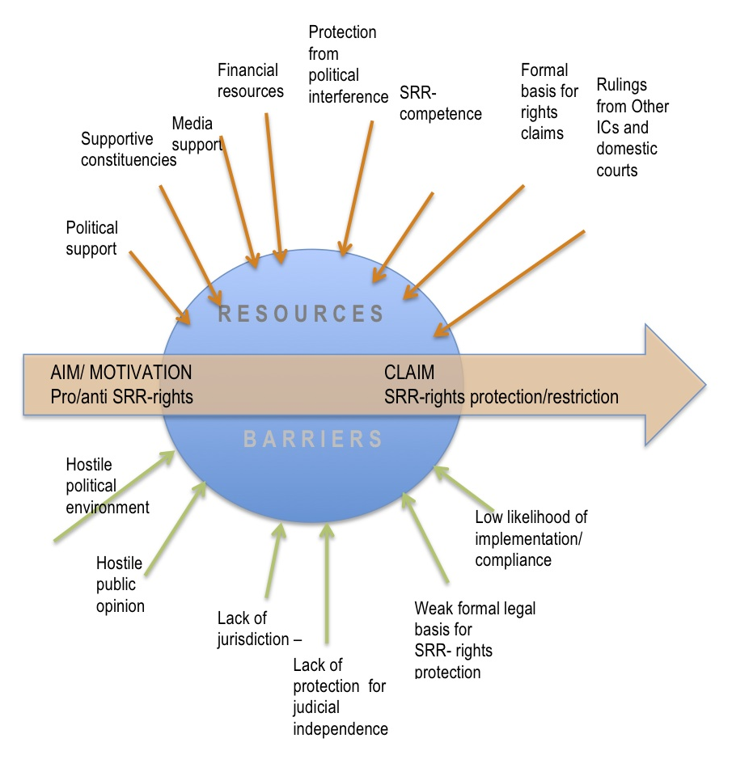

Several chapters in this book analyse the functioning of international adjudicators: international treaty bodies, the European and Latin American regional system; and the International Criminal Court. They describe how these bodies handle sexual and reproductive rights cases brought before them – selecting and deciding cases, devising remedies, and seeking to secure compliance with their judgements and authority for their role – and the analytic framework provides tools to better distinguish the factors that influence the adjudicators and understand why they act the way they do.
The analysis includes, most importantly a legal doctrinal perspective, mapping the existing jurisprudence and analysing the interpretive and institutional moves of adjudicators and other actors. To what extent and under what conditions do international judges actively advance their own interpretation of the core issues? When and how do they avoid deciding the cases on their merits, or with regard to their most controversial aspects, for example by ruling the case inadmissible; deciding it on narrow technical grounds; allowing the respondent state a margin of appreciation? And when and how do they actively seek to build acceptance for their decisions?
As laid out above, judges’ decisions are assumed to be influenced by their favoured outcome, their institutional epistemic and normative context, as well as the opportunity structure within which they decide these cases. To help shed light on the relative importance of institutional and strategic factors, and increase our understanding of the international adjudication processes in these cases, Box 3 sets out questions that can serve to unpack the process. Again, these can be addressed in different ways, including by analysing court documents (rulings, case files, amicus briefs - trough quantitative, qualitative and/or computational methods) and through key informant interviews.
3.4. Analysing compliance actors
When do governments, or other actors subject to international court orders (here termed compliance actors) act in accordance with the rulings? Why do they, in some cases, ignore, or act in defiance of court orders? And in other cases respond ´prematurely´ to litigation processes in anticipation of rulings, acting ‘in the shadow of ligation’? These are crucial questions to analyse in order to understand the effects of international litigation processes. Who the relevant compliance actors are - whether governing politicians, bureaucrats or private actors – and the nature and degree of their institutional embeddedness, will vary depending on the circumstances of the particular case and ruling. But the approach to the analysis is similar to what is outlined above: to deconstruct the choice situation of the compliance actor, get a sense of their motivation in the case (their preferred outcome); their situatedness, epistemologically and normatively (including their beliefs and professional values) – as well as of their opportunity structure (the incentives and barriers they face, and the resources they command).
Box 3: Probing international court functioning
- Which (types of) sexual and reproductive rights case have been brought before the international court, and by whom?
- Do the cases include amicus briefs (submissions from third parties/experts without an interest in the case, and if so from whom)?
- How has the international court decided sexual and reproductive rights cases before it?
  - What legal basis/sources do they rely on? Are they citing other international courts or domestic courts?
  - Have the cases been decided in narrow, technical terms? What have been the remedies?
  - Are there sexual/ reproductive rights-cases that have been deemed inadmissible?
- What might explain their decision-making? What does other literature indicate as to this court’s approach?
- Has the court followed up on their decisions, for example through formal or informal contact with judges or policy-makers at the national level?
The central question is: what make these actors comply - or not - with the orders of the international court? In some cases, the court order may align with the compliance actors’ internal motivation, even if the ruling goes against them, but in most cases, if they comply, it imposes a cost in the sense that they act differently from what they would want to do. They can do this based on a cost-benefit analysis (logic of consequence) where the political or reputational costs of going against the orders of the international court are seen to outweigh the gains (for example if the court has a protective constituency in other governments who might impose sanctions). They might also comply based on a logic of appropriateness, for example where actors steeped in a culture of legalism see compliance as the obvious or right response.
Analysing compliance actors and understanding their choices is central to the analysis of the effects of internationalised legal mobilisation and adjudication.

Analysing effects
As discussed in chapter 1, there are conflicting hypotheses with regard to the capacity of international litigation to affect social change and the case studies aim to further our understanding of under which circumstances the more optimistic liberal perspectives hold, as opposed to realists, and others who see litigation as a ‘hollow hope’ and a poor instrument for shifting power and effecting positive material or political change. But how effects are assessed depend a lot on what are considered relevant changes – and also on the geographical scope and time perspective adopted. A central concern of the book is to get a better grasp of the consequences of internationalised sexual and reproductive rights-lawfare, and the last part of the analytical framework regards the tracing of effects of international court decisions, and the broader litigation process.
To establish the effects of any form of litigation process is complex. Firstly, litigation is a multifaceted phenomenon in the sense that the effects may be of very different kinds – there will often be legal effects (changes in legislation or jurisprudence); there may also be other material effects on policy, administrative practices, access to services etc.; there may be political effects, including on the level of politicisation (or de-politicisation) of the policy field, the way decisions are made in relevant cases, or on the organisational strength of activist groups involved and the power-relations between them; and there may be ideational effects on public discourse and social attitudes. These effects can be direct, and materialise at the domestic level in the country where the case was initiated, but litigation processes may also have indirect effects, including on actors in other countries and at the international level. Effects may derive not only from the judgment. Even when a court case is lost or aborted, gains (or losses) can be made from the litigation process itself and associated mobilisation.
Given the highly politicised nature of these cases, it is particularly important to pay attention to possible backlash effects, where court cases trigger adverse social or political mobilisation, and where this results in a deterioration in policies or material conditions, that render litigants or the groups they represent worse off than they were when they took the case to court (Rosenberg 2008, Keck 2009; Eskridge 2013, Ura 2014). When analysing these processes it is crucial to carefully consider the time-perspective, as this will often affect extent to which there is a backlash or only a temporary setback.
Sexual and reproductive rights lawfare may also impact the legitimacy of international courts themselves. It may lead to negative politicisation - or popularity - of the tribunals with state governments or (segments) of the public. This in turn may affect the courts’ ability to generate compliance from government actors and affect the resources available for their operation. It may also affect international courts’ jurisdiction, if countries withdraw or there is a change in the mandate, as well as the legal weight and influence of their rulings. Hence, when assessing effects of international sexual and reproductive rights lawfare we should also consider the influence on the courts’ themselves, on their social legitimacy; their causal effectiveness; normative legitimacy and legal legitimacy.
In addition to the multiplicity of possible effects, it is a challenge to isolate the impacts of international litigation from other simultaneous developments, and to find good observable data. This volume does not aim to provide a complete analysis of the effects of international sexual and reproductive rights-litigation, but provides some windows onto the questions, using a variety of quantitative and qualitative methods.
To isolate impacts of litigation from other simultaneous developments, and to find good observable data, is challenging. Still, carefully crafted process-tracing analysis, utilising a combination of qualitative and quantitative approaches, and paying attention to intermediary as well as ultimate effects, may be fruitfully employed in establishing effects of lawfare (Mahoney and Goertz, 2005; Langford, 2017).
The case studies bring forth a qualitative analysis of effects of specific cases and litigation processes in particular countries, with an eye towards cross-border effects. These in turn, provide a basis for cross-country comparison to look for more systematic patterns. In this volume, this is complemented by a qualitative study from above, systematically tracing trans-national effects of particular judgments. The qualitative analyses – where processes are scrutinised in light of theoretical assumptions drawn from the literature in order to uncover mechanisms by which various types of influence is exerted, can be compared to studying effects in terms of ‘rings in the water’- tracing signs of effects of judgments and the litigation process along different dimensions as the process unfolds. While giving valuable insights into interactions and what we have earlier referred to as legal-political trigger-mechanisms, these process tracing analyses cannot provide robust information regarding how representative the findings are or the magnitude of the effects.
Quantitative analysis cannot provide the same analytical depth as qualitative field data, but can complement the qualitative analysis by providing more representative findings across cases (see Helfer and Voeten (2014) on impact of European LGBT litigation on national legislation in European). A major challenge here is to find valid and reliable data that can be compared across cases, but one approach that will be explored is analyses of legal diffusion effects of a (set of) international court judgment(s) across a set of domestic courts. Another possibility is to attempt to trace effects on public opinion.
This is a broad field, and which effects that are most relevant to explore, what it is possible to find data on, and which methods are most suitable will depend on the context. Box 4 lists questions that may serve as a starting point for exploring effects through key informant interviews, ethnographic studies, surveys, extant literature, and archival sources.
Box 4: Probing effects of internationalized lawfare
  - Did the litigation advance the stated long-term goal/cause of the litigant? Did the litigation advance bring short-term benefits for the litigant?
  - Were there (aligned or adverse) legislative or policy changes in response to the litigation/judgment? And, if so, to what extent have they been implemented?
  - Were there political actors who (successfully or unsuccessfully) sought to benefit from the momentum created by the litigation process
  - Did the litigation/judgment create media attention? And if so, what was the nature of the reporting?
  - Did the litigation/judgment create counter-mobilization – and if so if what form(s) (litigation, demonstrations, political action, bureaucratic resistance…)? Who are the main counter-mobilizing actors?
  - What was the impact of the litigation process on the activists/organisations involved? Did it strengthen them or create tensions? Did it strengthen their public standing – and standing vis-a-vis public authorities?
  - Has there been (are there plans for) follow-up litigation?
  - Have activists changed their views on the usefulness of litigation and/or of the international court/tribunal?
  - Have attitudes in the society changed towards the issues litigated/litigants/the international court changed since the litigation started?

Multiple sites and international dynamics
Adding to the complexity when analysing internationalised lawfare-processes as compared to other forms of litigation, is the dynamic that results from the fact that this forms part of a highly interactive and iterative strategic game. There are often dense interlinkages between actors within and across borders. As we have shown throughout the chapter, the concept of actors’ choice situation – within which more or less institutionally embedded and norm-driven actors make the decisions that drive and shape international litigation within highly contextual opportunity structures – is the central theoretical building block in the lawfare framework. These actors are not, however acting in isolation. The theoretical framework conceptualises international lawfare as a dynamic and global process, where different actors and their shifting opportunity structures are closely interlinked. Figure 3 illustrates the overall scope of the framework – and of the analysis in this book – and the linkages between various aspects of this highly dynamic phenomenon.
Figure 3: Internationalised sexual & reproductive rights-lawfare: global dynamics and actors
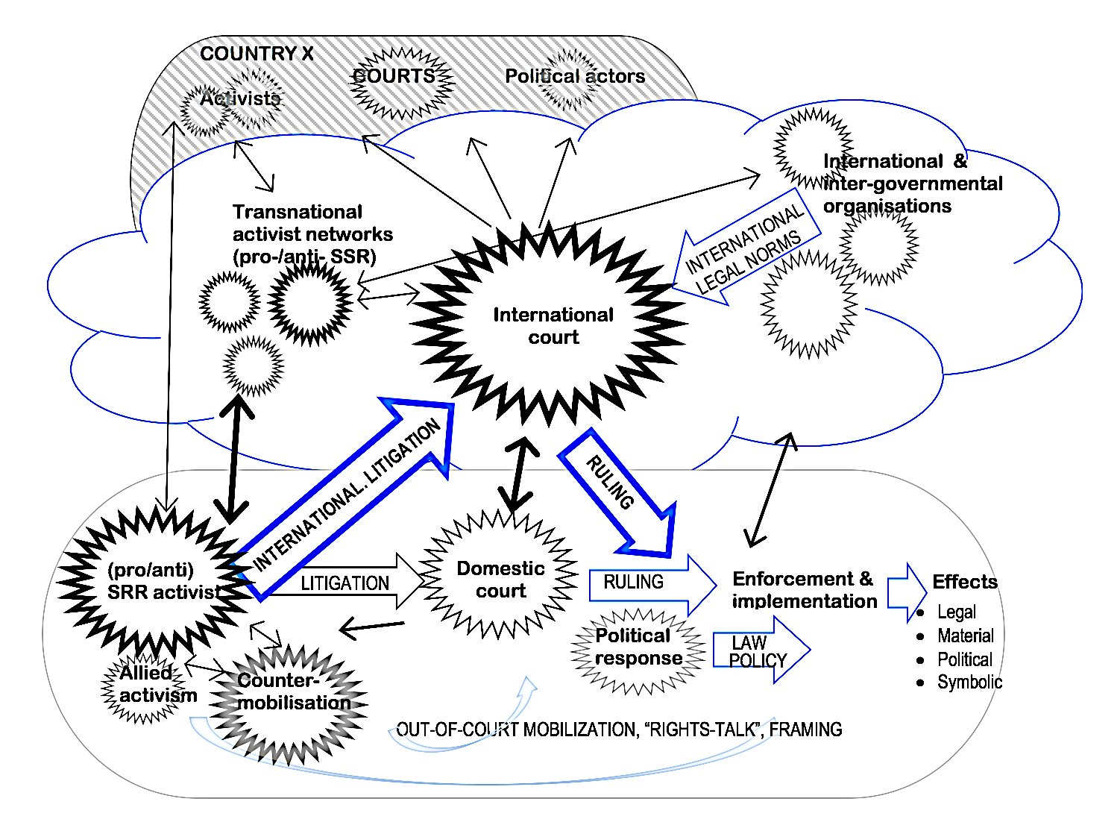

The circles in the figure represent the various actors involved in internationalised lawfare processes, as discussed throughout this chapter. The jaggedness of the circles illustrates that the choices the actors make are informed by their respective – changeable and interlinked – opportunity structures. The broad arrows indicate formal processes and decisions, while the simple arrows represent less formal, but not necessarily less important relations and sources of influence and resources. That some circles and arrows are drawn in bold, simply indicate that they are the main focus of discussion here and central to the analysis of sexual and reproductive rights lawfare in this volume.
The oval making up the lower part of Figure 3 represents the domestic context from which a case before an international court arises. On the left-hand side is the litigant, pictured within a jagged circle to illustrate that the decision to litigate, both the original decision to go to the domestic courts and the later decision to appeal to the international level was made within a particular opportunity structure, which is also influenced by (anticipated) actions of other, opposed and aligned actors in the field (as indicated by the two-way arrows between them). The domestic court is pictured in the centre of the domestic system, while political and administrative actors who are respondents in the case and whom rulings are made against - or for - are pictured on the right-hand side. Surrounding the litigant, are other civil society actors concerned with the cause. They may engage in various out-of-court actions to support the case, as may the litigant, including related litigation, lobbying and media-campaigns (illustrated by the curved grey arrows in the lower part of the figure, representing non-institutionalised forms of activism). But they may also mobilise in similar ways against the case – in courts, in the media, in churches and though political lobbying. The broader process at the domestic level is iterative, dynamic and multi-sited, and analyses should seek to uncover how the international litigation responds to previous contestations and how it (aims to) position actors for subsequent rounds.
The middle (cloud-shaped) section of Figure 3 represents the international system with the international court at the centre. This may be any international or regional court, tribunal or treaty body that is the site of sexual and reproductive right litigation. The jagged circle around the court, illustrates the opportunity structure of judges on a particular international court, who, as discussed above, also have range of legal and political considerations weighing in as they make their decisions.
The international court is surrounded by, and may form parts of networks and epistemic communities with other actors operating at the international level, and who are active in relation to the contested issue that is the subject of the court case (Slaughter 2003; Slaughter & Zaring 2006; Maja’a & Cross 2013). This includes inter-governmental bodies involved in norm-setting and policy-making; transnational activists engaging in advocacy and lobbying, and their supporters and funders. All these actors; transnational activists, judges on international courts, and representatives on governmental bodies also have relations to domestic counterparts, formal ties as well as informal networks and sources of influence and resources When analysing international lawfare processes, it is central to understand the nature of these ties, and how they play into the epistemological and normative situatedness of the different actors, as the opportunity structures of the various actors – and to assess how this affects the international lawfare at each stages in the initiation and articulation of the litigation, in the operation of the court, and in the various types of effects that litigation processes and international court rulings may set in motion.
Given the profoundly political nature of contestations over sexual and reproductive rights, it is particularly important to take account of the political trigger-mechanisms and effects. Each aspect of a lawfare process, potentially affects the opportunity structure of adversaries and allies, influencing their strategies and tactics in different arenas – which in turn may profoundly reshape the actor’s own opportunity structure in the next round. In cases of internationalised sexual and reproductive rights lawfare, a court case is usually part of a broader, iterative, multi-sited struggle, and may be an auxiliary strategy aimed at a limited, tactical goal – such as alliance-building for a mainly political or social mobilisation strategy. Short-term gains can result in long-term losses, or the opposite. This means that it is important to adopt a broad scope, geographically and timewise, in order to capture ripple effects beyond the individual court case.
It is also important to take into account that these relations and patterns of influence are not bilateral. A case brought before an international court may have been influenced by and have implications for actors in countries other than that from which the case arose. This can take many forms, from cross-national borrowing or collaboration on legal strategies, via legal and social mobilisation triggered by the case, to the domestic influence of the jurisprudence coming out of the case in third countries. In Figure 3, ‘third countries’ are represented collectively by the striped oval at the top, more tentatively sketched but indicating that the same types of dynamics and actors - activists, judges, political actors - are relevant here as in the ‘home country’ of the case (in the lower part of the figure).
One type of influence that is omitted from the figure, but that nevertheless is potentially significant and worth exploring, is the relationship between different international courts. International courts may dialogue and influence each other, through their judgments, for example by citing each other, but also in more informal and subtle ways (Slaughter 2003, Burke-White, W 2003). In this book, inter-court relations are explored most extensively in the chapter on the Toonen case, where Langford and Creamer explore the jurisprudential legacy of this case, which was decided by the UN Human Rights Committee (UNHRC) in 1994.
The book chapters differ with regard to which part of the overall framework in Figure 3 their analysis zooms in on, but given the interlinked and dynamic nature of these processes, each chapter is important to understand the phenomenon of international sexual and reproductive rights lawfare as a whole, and the questions explored in one chapter provides analytical material for other parts. In the following we will look more closely at the practical application of the framework.

Concluding reflections
International sexual and reproductive rights lawfare refers to situations where actors engaged in struggles to expand, defend – or restrict – rights related to reproduction, sexual orientation or gender identity use litigation before international courts as part of their repertoire of strategies. In this chapter, we have argued that the concept provides a useful basis for empirical analysis by bringing attention to the potentially multi-sited and iterative nature of the contestations that surface as individual cases in international courtrooms. It also brings attention to the interconnectedness of allied and opposing actors, nationally and transnationally, and to the importance of considering the actors’ long-term goals and strategies when analysing isolated actions. A court case may, for example be a short-term tactic aimed at generating attention and public support, create alliances, or obstruct an opponent rather than a direct strategy to reach the ultimate aim.
The aim of this chapter has been to develop a framework for understanding internationalised lawfare processes generally and with regard to sexual and reproductive right in particular. These are legalised contestation over social change that use international courts a site of struggle and the framework seeks to facilitate an analysis of what drives the use of law and of legal arenas as tools and sites of contestation; what influences the responses of judicial, political and administrative actors; and how to best assess the nature and extent of political, legal, ideational and material effects.
The framework presented here may contribute towards analyses of legal mobilisation more generally, but is particularly developed to suit the needs of situations of internationalised lawfare, where two of more sets of actors are engaged in long-term ideological battles fought out (partly) in international legal arenas. The particular challenge here, is to properly take account of the iterative, multi-sited, dynamic and profoundly political nature of these processes, with interlinked legalised contestations taking place in different arenas, and where the strategies and tactics of the different actors feed off each other, and re-shape future opportunity structures of friends and foes – and where tactical positioning for future battles may be the central aim of a particular litigation process or other instance of lawfare.
The systemic and dynamic nature of lawfare processes render them messy and at times even overwhelming to analyse, but in a context where lawfare is becoming an increasingly common mode of social and political contestation, there is an urgent need to develop analytical tools suited to the task.

References
Albiston, C. (2011), “The Dark Side of Litigation as Social Movement Strategy”, Iowa Law Review Bulletin, 96:61-77.
Bob, C. (2012), The Global Right Wing and the Clash of World Politics (New York NY: Cambridge University Press).
Bob, C. (2014), “The Global Battle over Religious Expression: Sweden’s Åke Green Case in Local and Transnational Perspective”, Journal of Ethnic and Migration Studies, 40/2: 212-229.
Burke-White, W. (2003). International legal pluralism. Mich. J. Int'l L., 25, 963.
Cichowski, R. A. (2013). Legal mobilization, transnational activism, and gender equality in the EU. Canadian Journal of Law & Society/La Revue Canadienne Droit et Société, 28(2), 209-227.
Cichowski, R. A. (2016). The European Court of Human Rights, Amicus Curiae, and Violence against Women. Law & Society Review, 50(4), 890-919.
Cummings, S.L. (2013), “Empirical Studies of Law and Social Change: What is the Field? What are the Questions?”, Wisconsin Law Review, 1: 171-204.
De Fazio, G. (2012), “Legal opportunity structure and social movement strategy in Northern Ireland and southern United States”, International Journal of Comparative Sociology, 53/3: 3-22.
Dorf, M. C., & Tarrow, S. (2014). Strange bedfellows: How an anticipatory countermovement brought same‐sex marriage into the public arena. Law & Social Inquiry, 39(2), 449-473.
Eskridge, W. (2013), “Backlash Politics: How Constitutional Litigation has Advanced Marriage Equality in the United States”, Boston University Law Review, 93: 275-323.
Epstein, L., & Knight, J. (2013). Reconsidering judicial preferences. Annual Review of Political Science, 16.
Epstein, L., & Knight, J. (1997). The choices justices make. Sage.
Fioretos, O., Falleti, T.G. & Sheingate, A. eds. (2016) The Oxford handbook of historical institutionalism. Oxford University Press.
Ginsburg, Tom (2014). "Political constraints on international courts." in Romano, C., Alter, K. & Shany, Y eds. The Oxford handbook of international adjudication. Oxford University Press. pp 483-502.
Gloppen, S. (2015) “Studying Courts in Context: the role of non-judicial institutional and socio-political realities” in LD Haglund & R Stryker, (eds) Economic, Social, and Cultural Rights: Emerging Possibilities for Social Transformation. University of California Press.
Gloppen, S. (2017) “Conceptualizing Lawfare”, presented as Dialogues in Constitutional Law (Universisty of Sao Paulo, Brazil, 9 November 2017).
Helfer, L. and Voeten, E. (2014), “International Courts as Agents of Legal Change: Evidence from LGBT Rights in Europe”, International Organization, 68/1: 77-110.
Hilson, C. (2002), “New social movements: the role of legal opportunity”, Journal of European Public Policy, 9/2: 238-255.
Keck, T. (2009), “Beyond Backlash: Assessing the Impact of Judicial Decisions on LGBT Rights”, Law & Society Review, 43/1: 151-185.
Keck, M. and Sikkink, K. (1998), Activists Beyond Borders (New York NY: Cornell University Press).
Kitschelt, H. (1986), “Political Opportunity Structures and Political Protest: Anti-Nuclear Movements in Four Democracies”, British Journal of Political Science, 16/1: 57-85.
Klarman, M. (2004), From Jim Crow to Civil Rights – The Supreme Court and the Struggle for Racial Equality (New York NY: Oxford University Press).
Klarman, M. (2005), “Brown and Lawrence (and Goodridge)”, Michigan Law Review, 104: 431-490.
Kouma, K. (2009), Globalizing the Culture Wars: U.S. Conservatives, African Churches, & Homophobia, (Sommerville MA: Political Research Associates).
Kouma, K. (2012), Colonizing African Values. How the US Christian Right is Transforming Sexual Politics in Africa. (Sommerville MA: Political Research Associates)
Kouma, K. (2013), “The Marriage of Convenience: The U.S. Christian Right, African Christianity, and Postcolonial Politics of Sexual Identity”, in M. Weiss and M. Bosia (eds.) Global Homophobia (Chicago: University of Illinois Press), 75-10
Kriesi, H., R. Koopmans, J. Duyvendak, and M. Giugni (1995), New social movements in Western Europe: a comparative analysis (Minneapolis MN: University of Minnesota Press).
Langford, M. (2015), “The New Apologists: The International Court of Justice and Human Rights” Retfærd, vol. 48, No. 1, pp. 49-78.
Langford, M., Rodríguez-Garavito, C., & Rossi, J. (eds.). (2017). Social Rights Judgments and the Politics of Compliance: Making it Stick. Cambridge University Press.
Langford, M. (2017), “Interdisciplinarity and Multimethodism”, in B.A. Andreassen, H.O. Sano and S. McIerney-Lankford (eds.), Human Rights Research Methods, Edward Elgar, 161-191.
Langford, M., & Behn, D. (2018). Managing Backlash: The Evolving Investment Treaty Arbitrator?. European Journal of International Law, 29(2), 551-580.
Law, D. & M. Langford (2023), Research Methods in Constitutional Law: A Handbook. Edgar Elgar
Lemaitre, J. (2012), By reason alone: Catholicism, constitutions, and sex in the Americas. International Journal of Constitutional Law, 10(2), 493-511.
Linos, K. and Twist, K. (2013), “Endorsement and Framing Effects in Experimental and Natural Settings: The Supreme Court, the Media and the American Public”, UC Berkeley Public Law Research Paper No. 2223732
Mahoney, J. and G. Goertz (2006), “A Tale of Two Cultures: Contrasting Quantitative and Qualitative Research”, Political Analysis 14: 227-249.
Mai'a K, & Cross D. C. (2013). “Rethinking epistemic communities twenty years later”. Review of international studies, 39(1), 137-160.
March, JG. and JP. Olsen (1984), “The New Institutionalism: Organizational Factors in Political Life”, American Political Science Review, 78: 734-749.
McCann, M. (1994), Rights at work: Pay equity reform and the politics of legal mobilization (Chicago IL: University of Chicago Press).
McCann, M. (2006), “Law and Social Movements: Contemporary Perspectives”, Annual Review of Law and Social Science, 2: 17-38.
Merry, S. E. (2003). Rights talk and the experience of law: implementing women's human rights to protection from violence. Human rights quarterly, 25(2), 343-381.
Meyer, D. and Minkoff, D. (2004), “Conceptualizing Political Opportunity”, Social Forces, 82(4): 1457-1492.
Nollkaemper A. (2014) “Converstations among Courts: Domestic and International Adjudicators”) in Romano, C., Alter, K. & Shany, Y eds. The Oxford handbook of international adjudication. Oxford University Press, 2014. pp 483-502.
NeJaime, D. (2011), “Winning Through Losing”, Iowa Law Review, 96: 941-1012.
NeJaime, D. (2012), “The Legal Mobilization Dilemma”, Emory Law Journal , 61:663-736.
Rao, H., Morrill, C., & Zald, M. N. (2000). Power plays: How social movements and collective action create new organizational forms. Research in organizational behavior, 22, 237-281.
Rosenberg, G. (2008), The Hollow Hope: Can Courts Bring About Social Change? (Chicago IL: University of Chicago Press)
Schofer, E., et al. (2012). "Sociological institutionalism and world society." The Wiley-Blackwell companion to political sociology 33: 57.
Segal, Jeffrey A., and Harold J. Spaeth. The Supreme Court and the attitudinal model revisited. Cambridge University Press, 2002.
Siegel, R. B. (2006) "Constitutional culture, social movement conflict and constitutional change: The case of the De Facto Era. 2005-06 Brennan Center symposium lecture." California law review 94.5: 1323-1419.
Slaughter, A. M. (2003). “A global community of courts”. Harv. Int'l LJ, 44, 191
Slaughter, A. M., & Zaring, D. (2006). “Networking goes international: an update”. Annu. Rev. Law Soc. Sci., 2, 211-229.
Steinmo, S., Thelen, K., & Longstreth, F. eds. (1992) Structuring politics: historical institutionalism in comparative analysis. Cambridge University Press.
Sunstein, C. R. (1995). “Incompletely theorized agreements” Harvard Law Review, 108(7), 1733-1772
Tarrow, S. (1998), Power in Movement – Social Movements and Contentious Politics (Cambridge: Cambridge University Press).
Tarrow, S. (2001), “Transtnational Politics: Contention and Institutions in International Politics”, Annual Review of Political Science, 4: 1-20.
Tilly, C. (1998) "Social movements and (all sorts of) other political interactions–local, national, and international–including identities." Theory and society 27.4: 453-480.
Tsutsui, K., Whitlinger, C. and Lim, A. (2012), “International Human Rights Law and Social Movements: States’ Resistance and Civil Society’s Insistence”, Annual Review of Law and Social Science, 8: 367-396.
Ura, J.D. (2014), “Backlash and Legitimation: Macro Political Responses to Supreme Court Decisions”, American Journal of Political Science, 58 (1): 110-126.
Vanhala, L. (2012), “Legal Opportunity Structures and the Paradox of Legal Mobilization by the Environmental Movement in the UK”, Law & Society Review, 46 (3): 523-556.
Voeten, E. (2015). International Judicial Behavior. In Romano, C. et al eds. The Oxford handbook in Romano, C., Alter, K. & Shany, Y eds. The Oxford handbook of international adjudication. Oxford University Press, 2014. pp 550-568.
Wilson, B. and Cordero, J.C.R (2006), “Legal Opportunity Structures and Social Movements: The Effects of Institutional Change on Costa Rican Politics”, Comparative Political Studies, 39 (3): 325–351.
Zald, M.N., and J.D. McCarthy. (1979). "Social movement industries: Competition and cooperation among movement organizations."

* Professor of political science at the University of Bergen, Co-Director, CMI-UiB Centre on Law & Social Transformation and former political science coordinator at Pluricourts Centre of Excellence, University of Oslo.
As discussed in the introductory chapter, the term international courts, here include all international and regional courts, tribunals and treaty bodies.
The framework forms part of a collective effort to understand the increasingly salient phenomenon of lawfare through a number of interlinked research projects. The current volume is part of the PluriCourts Centre for the Study of the Global Judiciary (University of Oslo) but the framework also draws on research projects based at Centre on Law & Social Transformation (CMI & University of Bergen), funded by the Norwegian Research Council: Abortion Rights Lawfare in Latin America; Sexual and Reproductive Right Lawfare: Global Battles; and Political Determinants of Sexual and Reproductive Health in Africa. I want to acknowledge the contribution of Malcolm Langford and team members from across the globe, especially Paola Bergallo, Camila Gianella, Rachel Sieder, and Alicia E. Yamin. The lawfare concept was first developed in “Climate Change Lawfare” (Gloppen and StClair 2012).
Carlson and Yeomans (1975) is the earliest reference I have found.
The following paragraphs draw on Gloppen (2018), where you will find a more in-depth discussion of the lawfare concept and its genealogy.
Wikipedia entry for “Lawfare”, https://en.wikipedia.org/wiki/Lawfare Accessed on 25th September 2016.
See the webpage of The Lawfare Project www.thelawfareproject.org, (accessed on 25th September 2016) and Hertzberg 2010. For a critical analysis of this position see Gordon (2014).
SLAPP suit - strategic lawsuits against public participation - often claiming enormous damages, are typically used by firms to immobilize critics and deter protests, particularly in the environmental field (Abrams 1989).
Although, they caution that “ultimately, it is neither the weak nor the meek nor the marginal who predominate in such things. It is those equipped to play most potently inside the dialectic of law and disorder” (Comaroff and Comaroff 2006: 31).
Some chapter authors, writing in contexts where the lawfare concept is politicized, use alternative terms (legal mobilization; strategic litigation; movement-countermovement).
A more in-depth discussion of the typology of lawfare strategies is laid out in Gloppen (2017).
On ‘rights talk’ and the significance of legal consciousness, see for example Merry (2003).
On activist’s strategies for building alliances and mobilizing through transnational networks see Keck and Sikkink (1998); and on their role in internationalized litigation strategies see Cichowski (2013; 2016).
The understanding of the actors’ situatedness draws on theories of historical and sociological institutionalism (see, e.g. Steinmo et al (1992); Schofer et al (2012) and Fioretos et al 2016).
Se for example Merton (1959) and social movement theory on political opportunity structure (McAdam et al 1999; Meyer and Minkoff 2004; Tarrow 1998; Kitschelt 1986). On legal opportunity structures see for example Hilson 2002, Wilson and Cordero (2006), Vanhala (2012) or de Fazio (2012). For elaboration of how the concept of opportunity structure may be helpful in analysing the role of courts in context, see Gloppen (2015).
See, e.g., Kriesi, Koopmans, Duyvendak and Giugni (1995).
See March and Olsen (1984).
These decisions may be taken by individuals, or collectively, by organized activist groups (or, as we will discuss later by a bench of judges) as the outcome of more or less deliberative processes. This has implications for how motivations are formed and decisions reached. The lawfare framework, by being intentionally shallow or incompletely theorized, (Sunstein 1995) covers both and is compatible with methodological individualism as well as more relational and holistic positions. This is also important for the openness for rational choice based as well as institutional forms of explanations.
For an introduction to potentialy useful methodologies see Langford and Law (forthcoming)
For a discussion on transnational actors/ activists and social movements Tarrow (2001) offers a point of departure along with Sikkink and Keck (1998). Tsuitsui et al. (2012) discusses many of the linkages between local and transnational movement actors.
As explained in the introduction: we are interested in whether the lawfare processes that emerge in various countries and end up before international courts and treaty bodies - to advance or restrict SRR - reflect a global phenomenon. The existing literature suggests different answers: It could be a matter of mimicry and diffusion where American adversarial legalism and “culture war” is exported and where national civil society actors act as part of transnational networks (Bob 2012; Kouma 2013). It might also be explained by local path dependencies, historical institutionalism and the particular role of religion and religious actors in each society. Or, it could be a combination of the two - developments might be driven by strategic actors at national and international level seeking to maximise potential gains within existing domestic and transnational political and legal opportunity structures. If so, we would expect internationalized SRR lawfare to emerge where this is an accessible option and other avenues for SRR mobilization are closed, costly or unlikely to succeed – or where internationalized lawfare complements and increases the chances of success though other avenues.
For example, if they are insulated from powerful actors with regard to appointments, tenure; and finances; as well as with regard to the legal bases for their decisions; and the presence of powerful/significant constituencies who can be counted on to support the decision and/or the authority of the tribunal. See for example Voeten (2015)
This is the focus of the bulk of judicial behaviour literature. See for example Segal and Spaeth (2002); Epstein & Knight (1997; 2013).
See Gloppen (2014) for a more in depth discussion of judges’ opportunity structures.
Adverse court orders can, for example provide backing for unpopular policies that the government sees as necessary or desirable.
For discussions of this perspective please see McCann (1994; 2006), Cummings (2013), Eskridge (2013) and Keck (2009). Whereas most of the previously cited works focus on domestic courts, Helfer and Voeten (2014) explicitly discuss the effects of ECtHR judgments on other European Council members’ adoption of LGBT rights.
The main reference here is Gerald Rosenberg’s Hollow Hope (1991/2008). Klarmann (2004; 2005) also holds this realistic vision of courts.
See for example Rodriquz-Garavito (2011); Gloppen (2015); Langford et al (2017).
For an in-depth discussion of different types of effects, see Langford et.al. 2017. For discussions about the varying effects of court decisions see also Albiston (2011) and NeJaime (2011; 2012) who discuss effects of losing and winning in court and distinguish between internal (the movement and activists) and external effects (political system, laws or general public). For court decisions’ effect on public opinion, see for example (Linos and Twist 2013; Ura 2014).
Low awareness of international courts and international court decisions is a challenge for surveys. An experimental survey set up, where respondents are given information about the case and/or the international court and then probed for their opinions and attitudes is an alternative – although it gives information about the potential for societal effects and legitimacy, rather than the actual effects.
This may in turn allow us to identify more general causal mechanisms that may go some way towards explaining legal-political dynamics around internationalized sexual and reproductive rights litigation.
A range of international, regional and sub-regional courts and treaty bodies (ICs) are serving as arenas for sexual and reproductive rights-lawfare, such as the Inter-American Court of Human Rights (IACtHR); Inter-American Commission of Human Rights (IACHR); European Court of Human Rights (ECtHR); European Court of Justice (ECJ); African Commission on Human and People’s Rights (ACHPR); United Nations’ Human Rights Committee (UNHRC); the CEDAW Committee; and the International Criminal Court (ICC)
On the rise of legalised politics, see for example Hircshl (2004; 2008); Keck (2014).

