



RECLAIMING EARTH, RECLAIMING POWER:
DIALOGUES ON WOMEN, CHILDREN, AND NATURE’S RIGHTS IN ENVIRONMENTAL GOVERNANCE

23rd – 24th July 2026

Workshop Report

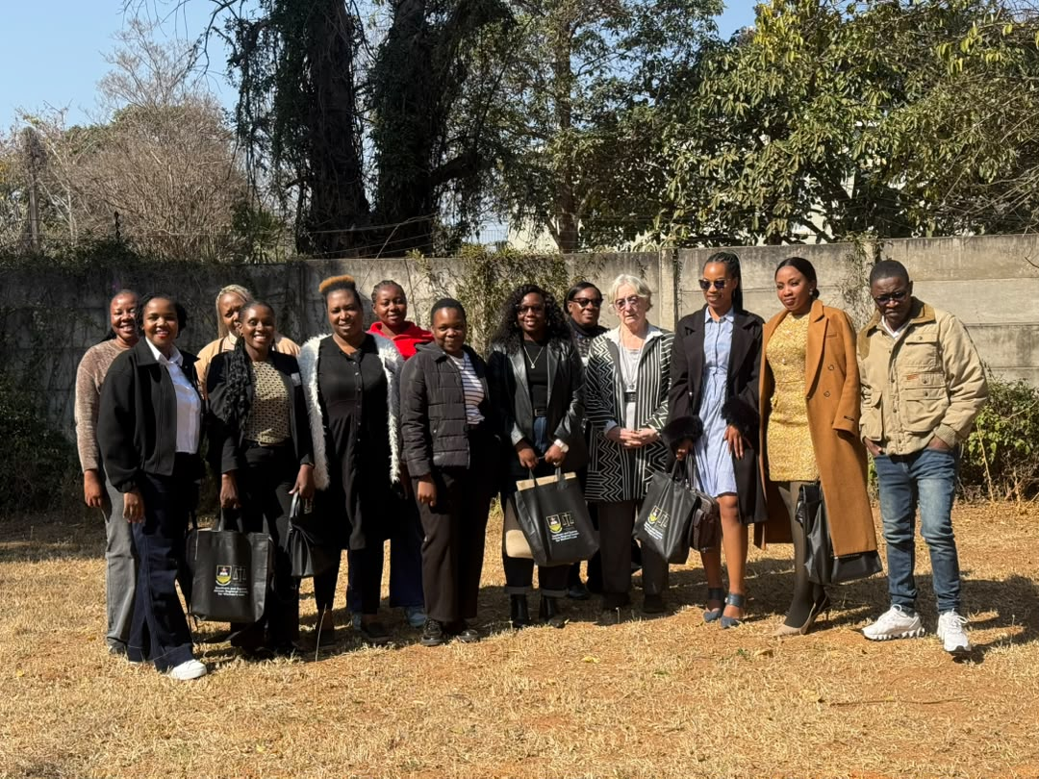

Submitted to: University of Zimbabwe Faculty of Law, Southern and Eastern African Regional Center for and Women and Children’s Rights (SEARCWL)

Submitted by: Lynet Tinoza, lynettinoza@gmail.com/ +263787095143

Date of submission: 29th July 2026

Executive Summary
The Reclaiming Earth, Reclaiming Power: Dialogues on Women, Children and Nature's Rights in Environmental Governance workshop conducted over two days centered on themes of Access to Justice, The Environment, Women, Children and the Law, Theories for Change in Environmental Justice, Resilience: Centering People, Community and Environmental Wellbeing, Power and the pursuit of agency in environmental governance and on the Empowered systems for Environmental Governance. Fifteen authors presented their abstracts under the themes and received expert peer review feedback, editorial guidance and recommendations with the aim of strengthening the papers submission for chapters of the forthcoming edited volume on Reclaiming Earth, Reclaiming Power: Dialogues on Women, Children, and Nature's Rights in Environmental Governance.

Session1 overall recommendations focused on the strengthening of rights based and feminist approaches within environmental governance frameworks, promoting meaningful participation of women, children and communities in environmental decision making, reexamining customary governance systems through a critical and transformative lens, advancing decolonial approaches to environmental justice and governance, strengthening legal pathways for environmental justice and accountability, preserving and promoting Indigenous languages and knowledge systems in environmental research and developing policy oriented research and advocacy pathways from academic work. Session 2 recommendations centered on promoting integrated and intersectional approaches to environmental governance, repositioning communities as knowledge holders and agents of environmental change, strengthening legal pluralism while advancing human rights and promoting context specific and African centred environmental governance models.

Session 3 recommendations focused on promoting people centred and community driven climate resilience, strengthening inclusive and participatory environmental governance, advancing child sensitive and gender responsive climate adaptation and policy development, recognising and integrating indigenous and community knowledge systems into resilience building, enhancing evidence informed and context specific research to inform climate policy and practice and fostering collaborative approaches that centre environmental wellbeing, community resilience and sustainable development. Finally session 4 recommendations centred on strengthening legal and institutional accountability for environmental governance, promoting inclusive, participatory and rights based governance systems that recognise women, adolescents, children and indigenous people as active rights holders and decision makers, enhancing policy coherence by integrating constitutional rights, climate finance and environmental governance reforms, investing in institutional capacity building and community empowerment to strengthen meaningful participation and advancing interdisciplinary, decolonial and evidence informed research that bridges law, policy, indigenous knowledge systems and practice to support transformative, equitable and sustainable environmental governance.

The workshop concluded with an editorial guidance session led by Professor Julie Stewart who provided practical recommendations to support authors in strengthening their draft chapters for publication in the edited volume. Drawing on her editorial experience, she encouraged authors to refine their papers by clearly articulating their central arguments, strengthening analytical depth and ensuring logical flow and coherence throughout their chapters. In her closing remarks, Dr. Mukumbiri commended participants for the high quality of scholarship, active engagement and collaborative spirit demonstrated throughout the workshop, noting that the discussions reflected the University of Zimbabwe's Strategic Plan and Education 5.0 agenda of producing impactful, evidence informed research that addresses contemporary societal challenges. As part of the agreed way forward, authors were requested to submit revised draft chapters by 31st August 2026 after which the manuscripts will undergo peer review and editorial refinement in preparation for publication.

Acronyms

AUCEVAWG African Union Convention on the Elimination of Violence Against Women & Girls
BIOFIN Biodiversity Finance Initiative
CRC Convention on the Rights of the Child
EIAs Environmental Impact Assessments
ESG Environmental, Social and Governance
FPE Feminist Political Ecology
IKS Indigenous Knowledge Systems
NDCs Nationally Determined Contributions
SRHR Sexual and Reproductive Health and Rights
TEEB The Economics of Ecosystems and Biodiversity
UNFCCC United Nations Framework Convention on Climate Change
WCNREG Women, Children and Nature's Rights in Environmental Governance
ZELA Zimbabwe Environmental Law Association
ZHRC Zimbabwe Human Rights Commission

_________________________________________________________________________

Introduction, Welcome Remarks and Objectives
The workshop commenced with welcoming remarks and introductions by Dr. Mukumbiri, who underscored the importance of examining the interconnected rights of women, children and nature within environmental governance. She highlighted that women and children continue to face systemic exclusion from environmental decision making processes with children's voices and perspectives remaining particularly underrepresented despite being disproportionately affected by climate change and environmental degradation. Against the backdrop of Zimbabwe's increasingly visible climate impacts including changing seasonal patterns, she emphasised the timeliness of the convening as a platform to rethink inclusive environmental governance. The workshop was designed to provide a participatory space for peer learning and constructive feedback on draft papers that will form chapters of the forthcoming edited volume, Reclaiming Earth, Reclaiming Power: Dialogues on Women, Children, and Nature's Rights in Environmental Governance. Participants were encouraged to engage in feminist dialogue on the intersections between the rights of women, children and nature, generate recommendations for gender responsive, child sensitive and rights based environmental governance and contribute to strengthening the quality, policy relevance and publication readiness of the papers. The convening also sought to foster a community of practice among researchers, policymakers, practitioners and civil society actors with the broader aim of advancing evidence informed advocacy, collaborative learning and sustained partnerships for inclusive environmental governance.

Keynote address Professor Julie Stewart
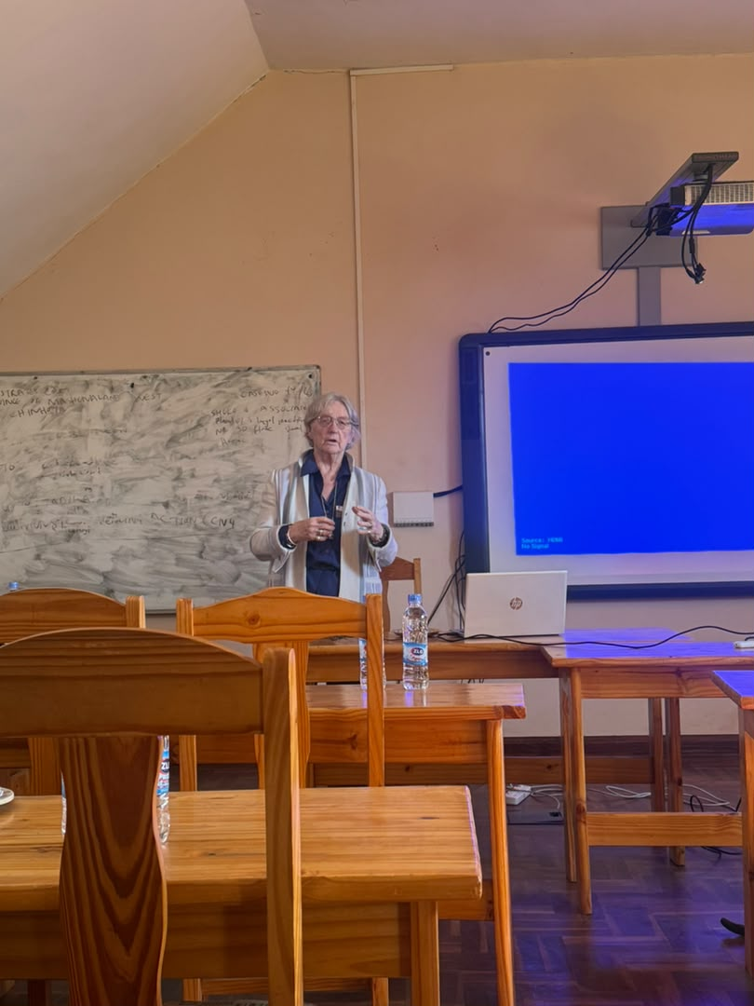
Professor Julie Stewart delivered the keynote address by challenging participants to rethink environmental governance through a more inclusive, feminist and rights based lens that recognises the interconnectedness of women, children and nature. She noted that mainstream environmental governance has traditionally treated these issues as separate legal and policy concerns resulting in the continued marginalisation of women and children in environmental decision making, the exclusion of indigenous knowledge systems and the treatment of nature primarily as a resource rather than a rights bearing entity. Framing the discussion around the Women, Children and Nature's Rights in Environmental Governance (WCNREG) conceptual framework, she emphasised that environmental governance should be understood as an interactive and interdependent system that interrogates relationships, responsibilities and power dynamics between people and the biosphere. Professor Stewart urged researchers to move beyond reactive policymaking where new environmental challenges often result in the creation of additional legal instruments without first generating the evidence needed to understand the underlying issues. Instead, she advocated for rigorous, interdisciplinary and context specific research that centres African feminist perspectives, decolonial thinking and community realities to inform transformative environmental governance.
Professor Stewart further highlighted that reclaiming environmental governance requires reclaiming women's power and children's entitlements by recognising them not merely as vulnerable groups but as active rights holders, environmental stewards and knowledge producers. She underscored the importance of documenting community experiences in indigenous languages to preserve cultural meaning and ensure that local knowledge is accurately represented, cautioning that translation can diminish the depth and significance of lived experiences. She outlined key research considerations for advancing the WCNREG framework including gender and sex analysis, intergenerational perspectives, geographical diversity, constitutional and legal mapping, institutional and structural analysis and strengthened South–South and South–North knowledge exchange to reshape global environmental discourse. Concluding with a call to action, Professor Stewart encouraged participants to develop research and policy solutions that challenge colonial legal legacies, recognise women, children and nature as interconnected rights holders and contribute to building an environmental governance system that is inclusive, evidence informed and grounded in African realities.
_________________________________________________________________________
Session 1: Access to Justice, The Environment, Women, Children and the Law

Memory Makuyana: From Norms to Reality: Structural Barriers to Women’s Access to Environmental Justice under the Maputo Protocol and AU CEVAWG Frameworks
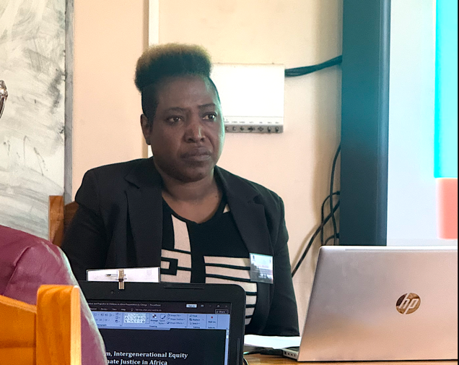
Participants commended the paper for presenting a compelling analysis of the structural barriers limiting women's access to environmental justice and for highlighting the implementation gap between regional human rights commitments and lived realities. The discussion generated constructive feedback aimed at strengthening the paper's conceptual framing and practical recommendations.
Discussion Points: A key area of discussion focused on the role of indigenous knowledge systems within environmental governance. Participants challenged the paper to critically examine the complexities of relying on customary knowledge noting that while indigenous systems offer valuable ecological knowledge and community based approaches to environmental stewardship some customary practices remain patriarchal and continue to undermine women's rights including access to land ownership and decision making. It was therefore recommended that the paper adopts a more nuanced approach by recognising both the strengths and limitations of indigenous knowledge systems and identifying pathways for promoting gender equality within customary governance structures.
Participants further encouraged the presenter to interrogate the historical origins of gender inequality within African societies. Rather than assuming that gender discrimination is inherently African, it was suggested that the paper explore whether many forms of women's marginalisation were reinforced or transformed through colonial legal systems. Several contributors noted that pre-colonial African societies often recognised women's significant social, spiritual and environmental roles including their association with fertility, water, agriculture and rain making ceremonies. The discussion therefore recommended strengthening the historical analysis by examining when and how women were gradually displaced from positions of environmental authority and governance.
The discussion also challenged prevailing narratives portraying African women as historically powerless. Participants observed that many traditional governance systems were organised around complementary social roles and age based hierarchies rather than rigid gender exclusion. While acknowledging the existence of inequalities, participants encouraged the presenter to avoid reproducing simplified narratives of perpetual female marginalisation and instead examine how women exercised authority and agency within indigenous governance systems. This would provide a stronger foundation for proposing governance reforms that build upon existing African knowledge systems rather than replacing them.
Participants and peer reviewers agreed that while the paper clearly articulated the structural barriers to environmental justice, greater emphasis should be placed on developing practical and transformative solutions. Recommendations included proposing governance models that move beyond identifying problems towards outlining actionable legal, institutional and community based reforms. Participants also reflected on feminist advocacy strategies questioning whether approaches centred solely on confrontation sufficiently address women's lived realities. Instead, it was suggested that the paper explore context specific approaches that combine negotiation, community dialogue and structural reform while remaining responsive to the diverse struggles experienced by African women. Overall, the peer review reinforced the importance of grounding environmental justice within African feminist thought, decolonial perspectives and community driven governance solutions that advance substantive rather than merely formal equality.
_________________________________________________________________________
Chingasiyeni Govhati: Legal Pluralism, Intergenerational Equity and Climate Justice in Africa: Children as Invisible Victims of Rural Climate Governance
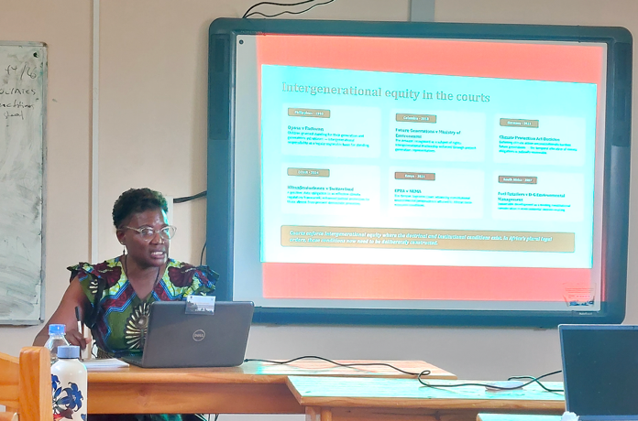
Participants welcomed the presentation for drawing attention to the often overlooked relationship between children's rights, climate justice and legal pluralism, describing it as an important contribution to emerging debates on environmental governance in Africa. It was observed that the presentation together with earlier paper reflected the aspirations of Education 5.0 by demonstrating how legal scholarship can generate practical, policy oriented solutions to contemporary environmental challenges.
Discussion Points: A significant discussion focused on the role of customary law and its implications for children's participation in environmental governance. Participants observed that within many African customary systems, social status is determined largely by age rather than chronological maturity meaning that individuals may continue to be regarded as children irrespective of their knowledge or capacity to contribute to decision making. The presenter was encouraged to further interrogate how this cultural understanding of childhood can be reconciled with contemporary children's rights frameworks that advocate for meaningful participation in environmental governance.
Participants also encouraged the presenter to strengthen the constitutional dimension of the paper by examining how existing constitutional provisions particularly Sections 73 and 19 could be more effectively utilised to advance children's environmental rights within Zimbabwe and similar jurisdictions. Rather than focusing solely on identifying governance gaps, it was suggested that the paper explore constitutional pathways for integrating children's rights into climate governance and environmental decision making.
The discussion further emphasised the need to identify practical mechanisms that would enable children to participate meaningfully in environmental governance within their communities. Participants questioned how administrators, policymakers and traditional leaders could create inclusive governance processes while respecting customary structures and recognising those who traditionally hold environmental knowledge. This highlighted the importance of balancing respect for indigenous governance systems with the need to ensure children's voices are heard in decisions that directly affect their present and future wellbeing.
Participants and peer reviewers recommended strengthening the paper's discussion on strategic litigation by identifying factual scenarios and case studies capable of advancing children's environmental rights within African regional human rights systems. It was suggested that the research could contribute to the development of future communications or jurisprudence on children's climate rights before regional human rights bodies thereby helping to establish an African legal framework that explicitly recognises climate change as a children's rights issue. Overall, the discussion reinforced the importance of developing context specific legal, institutional and community based solutions that bridge statutory and customary governance systems while placing children's rights and intergenerational justice at the centre of environmental governance.
_________________________________________________________________________
Ashton Mufari: Reimagining Zimbabwean Environmental Law and Governance Through Decolonial Lenses
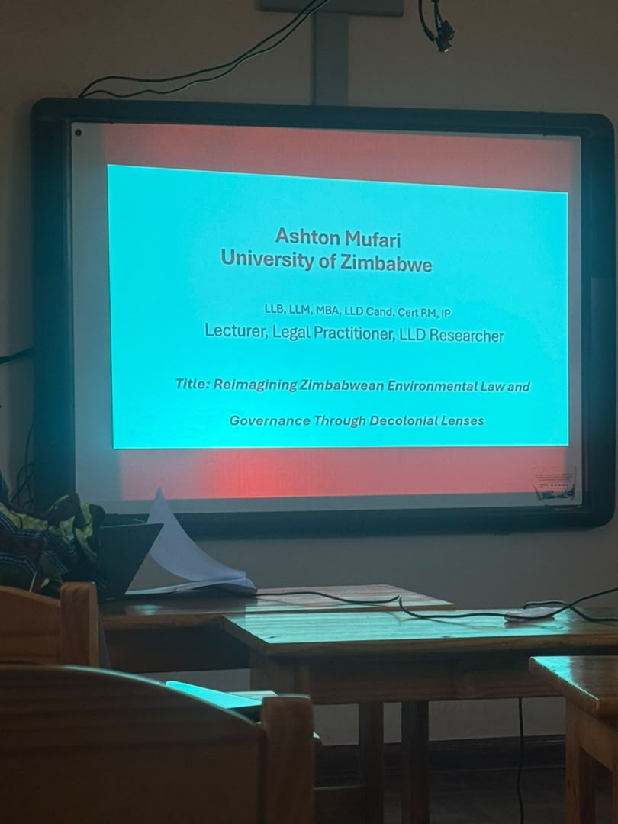
Participants welcomed the presentation for providing a timely and thought provoking critique of Zimbabwe's environmental governance framework and for demonstrating how colonial governance structures continue to influence environmental law and policy. The discussion acknowledged the paper's strong decolonial perspective and particularly commended its inclusion of an intergenerational dimension while encouraging the presenter to further strengthen the practical pathways for translating decolonial theory into community led environmental governance.
Discussion Points: A key area of discussion centred on ensuring that environmental advocacy originates from communities themselves rather than being driven solely by academic institutions. Participants questioned how communities could be empowered to recognise environmental challenges, mobilise around them and become active agents of environmental governance. It was recommended that the paper place greater emphasis on community ownership, grassroots mobilisation and participatory approaches that enable local people to shape environmental solutions based on their lived experiences and priorities.
Participants also highlighted the importance of language and knowledge preservation within decolonial research. It was noted that documenting community experiences in indigenous languages preserves the richness, cultural context and authenticity of local knowledge, while translation alone may fail to capture important meanings and worldviews. The discussion encouraged the presenter to recognise indigenous languages not only as communication tools but also as repositories of ecological knowledge that can strengthen both local research and global environmental discourse.
Further recommendations encouraged the presenter to broaden the scope of the legal analysis by considering whether aspects of criminal and environmental legislation also reflect colonial governance approaches and therefore require decolonisation. Participants suggested that expanding the discussion beyond environmental governance institutions would provide a more comprehensive understanding of how colonial legal legacies continue to shape environmental justice within Zimbabwe.
A recurring theme throughout the discussion was the need to strengthen the paper's treatment of indigenous knowledge systems and ecocentrism. Participants observed that many indigenous environmental practices including customary beliefs, myths and taboos historically functioned as effective systems for regulating access to natural resources and preventing environmental degradation. These practices recognise the intrinsic value of nature and reflect an ecocentric worldview in which humans exist as part of rather than separate from ecological systems. Participants therefore encouraged the presenter to frame indigenous knowledge not as an alternative to scientific knowledge but as a complementary governance resource that can contribute to more sustainable and culturally grounded environmental management. Overall, the discussion reinforced the need for decolonial environmental governance that redistributes decision making power, values indigenous knowledge and empowers communities to become central actors in protecting both people and nature.
_________________________________________________________________________
Tsitsi Masengure: Integrating Children’s rights into the new climate laws: The proposed Climate Change Management Bill, as an opportunity to incorporate international child rights standards into its frameworks on carbon trading and emissions

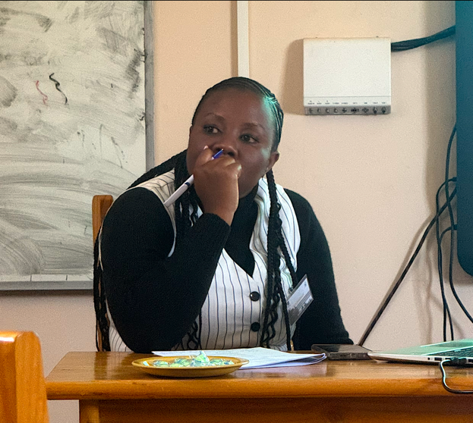
Participants welcomed the discussion on integrating children’s rights and gender equality into Zimbabwe’s emerging climate governance frameworks, noting that the proposed Climate Change Management Bill presents a timely opportunity to strengthen environmental legislation through a human rights based approach. The discussion acknowledged the importance of ensuring that climate laws do not only focus on environmental management, carbon trading and emissions reduction but also consider the rights, needs and lived realities of children, young people, women and other vulnerable groups who are disproportionately affected by climate change.
Discussion Points: A key area of discussion centred on the need to align the Climate Change Management Bill with international and regional child rights standards recognising children as rights holders and active participants in climate governance rather than only as vulnerable groups requiring protection. Participants highlighted the importance of embedding principles such as children’s participation, non-discrimination, protection and the right to a safe and healthy environment within climate policy frameworks. It was recommended that the Bill include clearer provisions for meaningful engagement of children and young people in climate decision making processes and climate action initiatives.
Participants further emphasised the importance of integrating a gender responsive lens within climate legislation and governance structures. The discussion recognised that climate change impacts are experienced differently by women, girls, boys and marginalised communities due to existing social and economic inequalities. Participants recommended that the Bill explicitly address gender considerations, including women’s and girl’s participation in climate governance, equitable access to climate finance, protection from climate related vulnerabilities and the inclusion of gender perspectives in adaptation and mitigation strategies.
Another key recommendation was the development of a policy brief from the paper by the author as a strategic advocacy pathway to influence the ongoing legislative process. Participants noted that Parliament remains open to stakeholder contributions and encouraged the development of evidence based recommendations that identify gaps and propose practical opportunities for strengthening the Bill. The policy brief was highlighted as a tool to engage policymakers, parliamentary committees and relevant stakeholders by positioning child rights and gender integration as critical components of effective and inclusive climate governance.
Participants also recommended exploring collaboration with the Zimbabwe Human Rights Commission (ZHRC) particularly through its dedicated working group focused on human rights issues, as a strategic partner in advancing advocacy efforts. The Commission was identified as an important platform for promoting a rights based approach to climate legislation, supporting dialogue, generating evidence and strengthening accountability mechanisms around the protection of children’s rights and gender equality within climate action.
Overall, the discussion reinforced the need for climate governance frameworks that are inclusive, participatory and grounded in human rights principles. Participants emphasised that integrating children’s rights and gender equality into Zimbabwe’s climate legislation would strengthen the country’s ability to respond to climate change in a manner that promotes justice, equity and resilience while ensuring that the voices and experiences of affected communities are reflected in environmental decision making.
Key Recommendations from Session 1

The discussions across the presentations highlighted the interconnected nature of environmental justice, human rights, gender equality, children’s rights and the rights of nature. The peer review emphasised that advancing inclusive environmental governance requires moving beyond traditional environmental protection approaches towards governance frameworks that address historical inequalities, strengthen accountability and place affected communities at the centre of decision making. The following cross cutting recommendations emerged from the session:
- Strengthen Rights-Based and Feminist Approaches within Environmental Governance Frameworks: Authors were encouraged to strengthen their papers by demonstrating how environmental governance can move beyond technical approaches focused solely on conservation, climate management or resource regulation towards approaches that recognise environmental justice as inseparable from the protection of human dignity, equality, participation and accountability.
- Promote Meaningful Participation of Women, Children and Communities in Environmental Decision making: A recurring theme across the session was the need to move from participation as consultation towards genuine inclusion where women, children and communities are recognised as knowledge holders, rights holders and active agents of environmental governance. The discussion emphasised that children should not be viewed only through a vulnerability lens but should be recognised as contributors with valuable perspectives particularly on issues affecting their future wellbeing and intergenerational justice.
- Re-examine Customary Governance Systems through a Critical and Transformative Lens: Participants highlighted the importance of engaging with indigenous and customary governance systems as important sources of environmental knowledge and community based stewardship. However, discussions emphasised the need for a balanced and critical approach that recognises both the strengths and limitations of customary systems. The session reinforced that indigenous knowledge should be viewed as complementary to scientific knowledge, providing culturally grounded approaches to understanding and protecting ecological systems.
- Advance Decolonial Approaches to Environmental Justice and Governance: The peer review emphasised the importance of examining how colonial legal and governance structures continue to shape contemporary environmental decision making. Discussions highlighted that environmental injustice cannot be fully understood without considering historical processes that influenced land ownership, resource control, legal systems and community authority. The session highlighted that decolonisation should move beyond critique and contribute to practical models that restore agency, strengthen accountability and support community led environmental governance.
- Strengthen Legal Pathways for Environmental Justice and Accountability: It was recommended that there should be greater attention to the role of law as a tool for advancing environmental justice and protecting the rights of women, children and nature. While many papers highlighted gaps in existing legal frameworks, participants encouraged authors to further develop practical legal pathways for reform and accountability. It was noted that research should contribute not only to identifying governance challenges but also to proposing actionable legal and institutional solutions.
- Preserve and Promote Indigenous Languages and Knowledge Systems in Environmental Research: The peer review highlighted language as an important component of environmental justice and knowledge preservation. Discussions noted that indigenous languages carry ecological knowledge, cultural values and community histories that may be lost through translation or external interpretation. This was identified as essential for strengthening locally grounded environmental governance approaches.
- Develop Policy-Oriented Research and Advocacy Pathways from Academic Work: Authors were encouraged to strengthen the policy relevance of their papers by developing clear pathways for translating research findings into advocacy, legislation and practice. The session emphasised that academic research should serve as a bridge between knowledge generation and transformative action.

Session 2: Theories for Change in Environmental Justice
Jacqueline Nechavava: Entangled Vulnerabilities: An African Feminist Critique of Environmental Governance: Bridging Women’s, Children’s and Nature’s Rights in Zimbabwe
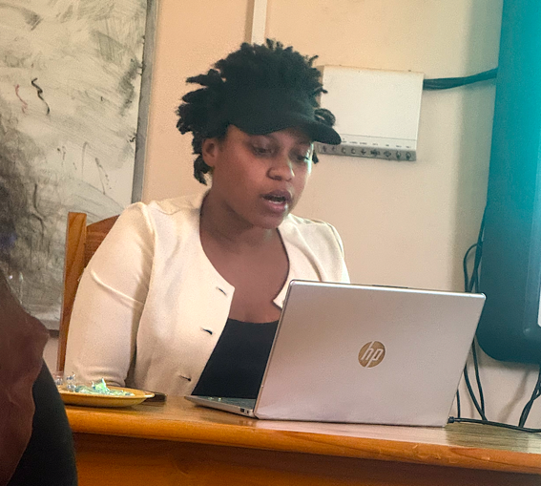
Participants welcomed the presentation for offering a compelling African feminist critique of environmental governance and for highlighting the interconnected relationship between women’s rights, children’s rights and the rights of nature within Zimbabwe’s environmental justice landscape. The discussion acknowledged the paper’s strength in challenging dominant approaches that treat environmental governance as separate legal and policy domains, while demonstrating how colonial and post-colonial legal systems have contributed to the marginalisation of women, children and nature. Participants particularly appreciated the paper’s focus on rural and peri urban women’s experiences, children’s intergenerational claims to a clean environment and the exclusion of customary knowledge systems from mainstream environmental governance.
Discussion Points: A key area of discussion focused on strengthening the paper’s conceptual framing around legal pluralism and decolonialism, which emerged as cross cutting themes throughout the workshop. Participants noted that the paper provides an important opportunity to examine the interaction between statutory legal systems, customary governance structures and indigenous environmental knowledge. It was recommended that the author further explore how these different legal orders have shaped the relationship between communities, natural resources and environmental decision making while examining opportunities for creating more inclusive governance systems that recognise both customary knowledge and human rights principles.
Participants observed that while the paper presents a rich and comprehensive analysis, its scope is currently broad due to the wide range of issues being addressed. The author was encouraged to refine and narrow the focus by identifying the central argument that connects women’s rights, children’s rights and nature’s rights. It was suggested that the paper could be strengthened by centring the key question of how historical, legal and governance processes have resulted in the exclusion of women and children from environmental decision making and how nature can be recognised as an active rights bearing entity within these systems. This would allow for a clearer analytical pathway and stronger contribution to feminist environmental governance debates.
Participants further reflected on the framing of ‘vulnerabilities’ within the paper and cautioned against approaches that position women, children and communities primarily through a deficit based lens. While acknowledging the disproportionate impacts experienced by these groups, participants recommended reframing the discussion to also highlight agency, knowledge, leadership and resilience. The author was encouraged to consider alternative framing that recognises women, children and communities not only as affected groups but as active environmental actors, knowledge holders and contributors to environmental solutions.
A significant discussion centred on the inclusion of nature as a rights holder within environmental governance frameworks. Participants encouraged the author to strengthen the legal analysis by examining the practical implications of recognising rights of nature within Zimbabwe’s constitutional and legislative frameworks. The discussion highlighted the importance of exploring existing provisions such as Section 73 of the Constitution of Zimbabwe, which provides for environmental rights and considering how these could be expanded or interpreted to strengthen recognition of nature’s intrinsic value. Participants recommended that the paper further examine current legal limitations and identify pathways for addressing gaps in environmental protection through a rights based approach that recognises nature as more than a resource for human use.
Participants also encouraged deeper engagement with the relationship between customary governance systems and environmental justice. While recognising the value of customary knowledge and indigenous environmental practices, feedback highlighted the need to critically examine how customary systems can be balanced with principles of equality, inclusion and rights protection. The author was encouraged to explore how customary institutions can be strengthened as spaces for environmental stewardship while addressing practices that may limit women’s participation, ownership or decision making authority.
Further recommendations focused on strengthening the paper’s practical recommendations on access to environmental justice. It was noted that some proposed reforms may face implementation challenges within existing governance structures and encouraged the author to consider more context specific and achievable pathways. It was recommended that the paper examine existing mechanisms for addressing environmental violations within customary jurisdictions and focus on strengthening these systems rather than creating entirely new structures. This could include enhancing accountability mechanisms, strengthening community based environmental governance and improving coordination between customary and statutory justice systems.
Overall, the discussion reinforced the importance of positioning the paper within broader African feminist, decolonial and rights based environmental governance debates. Participants encouraged the author to refine the paper’s focus around the intersection of women’s rights, children’s rights and nature’s rights while developing practical pathways for transforming environmental governance systems. The paper was recognised as making an important contribution towards reimagining environmental justice in Zimbabwe by challenging fragmented approaches and advocating for governance models that recognise the interconnected wellbeing of people, communities and ecosystems.
_________________________________________________________________________

Tendai Mupudzi: Extractive Dust and Intergenerational Environmental Injustice: An African Feminist Critique of Lithium Mining Governance in Zimbabwe

Participants welcomed the presentation for drawing attention to the often overlooked environmental and human rights impacts associated with lithium mining transport corridors describing it as a timely and innovative contribution to environmental governance scholarship. The discussion commended the paper for shifting attention beyond mining sites to the less visible but equally significant impacts of extractive dust generated through the transportation of lithium. Participants recognised the paper's relevance in the context of Zimbabwe's growing role in the global energy transition and its potential to contribute to more comprehensive and equitable approaches to mining governance.
Discussion Points: A key area of discussion centred on the need to strengthen the paper's analysis of the lithium transport value chain. The peer review encouraged the author to provide greater detail on how lithium is transported from mining sites, the logistics involved and how transportation processes contribute to persistent dust pollution affecting communities along mining corridors. It was noted that understanding the movement of lithium beyond extraction would strengthen the paper's analysis of environmental governance gaps and provide a clearer basis for identifying targeted mitigation measures.
Participants further recommended expanding the institutional analysis by examining the roles and coordination of the various government ministries, regulatory agencies and state owned enterprises involved in mining, transport, roads, environmental protection and public health. The discussion highlighted that addressing extractive dust requires a coordinated, multi sectoral governance approach rather than isolated interventions by individual institutions. The paper was therefore encouraged to identify existing coordination gaps and propose stronger legal and institutional mechanisms capable of supporting long term environmental management and accountability.
The discussion also highlighted opportunities to strengthen the paper's legal analysis by exploring constitutional and strategic litigation pathways for addressing environmental harm. Participants encouraged the author to examine how Section 73 of the Constitution of Zimbabwe which guarantees the right to an environment that is not harmful to health or wellbeing, could be utilised to advance accountability for extractive dust pollution. It was further recommended that the paper interrogate whether existing Environmental Impact Assessments adequately assess and mitigate environmental impacts arising from transport corridors, rather than focusing primarily on mining sites and consider whether strategic litigation could contribute to strengthening compliance and enforcement.
Participants additionally encouraged the author to broaden the comparative legal analysis by drawing on regional jurisprudence and comparative case law, particularly from jurisdictions such as South Africa. It was noted that environmental legislation and policy reform often lag behind emerging environmental challenges, making judicial decisions an important source of guidance for strengthening governance frameworks. Comparative case law was recommended as a means of identifying good practices, strengthening legal arguments and informing recommendations for improving Zimbabwe's environmental governance in response to the rapid expansion of lithium mining.
Overall, the discussion reinforced the importance of recognising extractive dust as an environmental justice and intergenerational equity issue that disproportionately affects women, children and communities living along mining transport corridors. Participants encouraged the author to strengthen the paper by integrating legal, institutional and policy perspectives that promote coordinated governance, constitutional accountability and sustainable mitigation measures. The paper was recognised as making an important contribution to expanding environmental governance discourse beyond extraction sites and highlighting the need for more holistic approaches to regulating the full lifecycle of mining activities.
_________________________________________________________________________
Talent Viviane Fetso: Reimagining Environmental, Social, Governance through an African lens: A deep dive into Women’s Rights, Corporate Accountability, and ESG in Zimbabwe
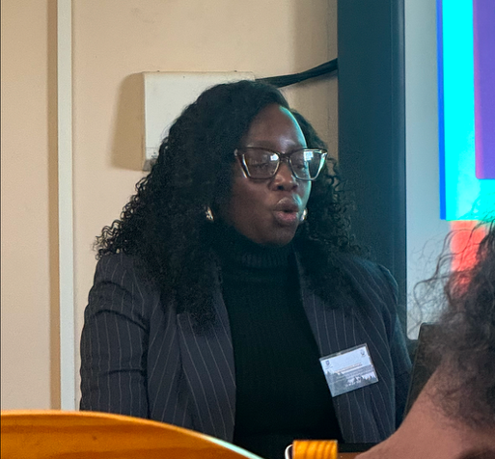
Participants welcomed the presentation for introducing the highly technical and emerging area of Environmental, Social and Governance (ESG) and for critically examining its relevance to women's rights, corporate accountability and environmental governance within the Zimbabwean context. The discussion recognised the paper's important contribution in challenging conventional ESG frameworks noting that while they have become influential global tools for measuring corporate sustainability and risk, they often prioritise investor interests over the rights, experiences and accountability demands of affected communities.
Discussion Points: A key area of discussion centred on the localisation and accessibility of ESG frameworks. Participants questioned whether ESG concepts have been sufficiently contextualised for ordinary citizens and local communities, particularly those directly affected by corporate activities. It was observed that communities such as Chitungwiza and other localities may have limited awareness or understanding of ESG despite being significantly impacted by environmental and corporate governance issues. Participants therefore encouraged the author to strengthen the paper by exploring how ESG principles can be translated into accessible, community centred approaches that empower citizens to understand, monitor and demand corporate accountability.
Participants also encouraged the presenter to strengthen the institutional analysis by examining the governance and accountability mechanisms responsible for implementing and monitoring ESG-related obligations, including the relevant Statutory Instrument (SI) of 2026. The discussion questioned whether adequate institutions, oversight mechanisms and enforcement structures currently exist to ensure compliance with ESG requirements. Participants recommended that the paper identify the responsible institutions, assess their mandates and capacity and examine how institutional coordination can be strengthened to improve implementation and accountability.
A further area of discussion focused on the legal foundations of ESG within Zimbabwe. Participants observed that current ESG requirements appear to derive largely from international standards and investor expectations rather than from a comprehensive domestic legal framework. The author was therefore encouraged to critically examine the source of ESG's legal authority within Zimbabwe and analyse the implications of relying predominantly on international standards in the absence of robust national legislation. Participants recommended exploring opportunities for domesticating ESG principles through national legal and policy frameworks that are responsive to Zimbabwe's social, environmental, and governance realities.
Overall, the discussion reinforced the importance of reimagining ESG through an African and rights-based lens that places women, communities and environmental justice at the centre of corporate accountability. Participants encouraged the author to move beyond describing ESG as a technical reporting framework and instead demonstrate how it can evolve into a governance tool that strengthens transparency, accountability, community participation and the protection of human rights. The paper was recognised as making an important contribution to ongoing debates on corporate governance by advocating for ESG approaches that are locally grounded, legally enforceable and responsive to the lived experiences of communities affected by corporate activities.
___________________________________________________________________________
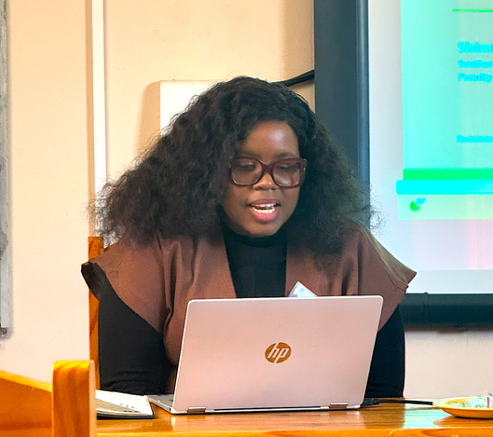
Shimtah Nembaware Women in grey zone of resource governance: Examining Gender Access Control and Benefit Sharing in Ward 17 Chimanimani Zimbabwe
Participants appreciated how the presentation interrogated what is termed a gendered “grey zone” of resource governance in Ward 17 (Biriri), Chimanimani, Zimbabwe. This grey zone emerging from the coexistence of statutory and customary legal systems, which operate without a clear hierarchy or consistent enforcement framework.
The presenter stated that while statutory frameworks formally guarantee gender equality, lived realities diverge sharply. Local authorities including chiefs, councilors and committee actors strategically alternate between legal systems (rule switching) to delay, deflect or deny women’s claims to land and natural resources. According to the presenter this creates a structural contradiction where women are central to ecological labor and household survival yet they remain marginalized in ownership, control and benefit-sharing
According to the research the scale of exclusion is reinforced by extremely low female representation in leadership structures and the heavy dependence of households on natural resources for livelihoods. The central research puzzle was on how plural governance systems shape women’s access, control, and benefits and how women navigate and resist these constraints.
Discussion points: The discussions from participants and expert reviewers were that the study explores tangible policy and practice implications through proposing context specific, African led interventions aimed at strengthening documentation through mobile registration clinics, same day documentation services and mandatory cosigned written records for land allocations. Another commended theme was on enhancing participation spearheading the reserved agenda time for women and youth and mandatory written responses to women’s proposals. Themes such as ensuring transparency and accountability through direct payments to women beneficiaries, public disclosure of resource flows and accessible grievance mechanisms linked to independent institutions were explored through the discussions. Recommendations included the potential to leveraging local tools such as engaging with the Zimbabwe Gender Commission as an accountability mechanism and exploring further publishing the research for wider reach.

Key Recommendations from Session 2
Across the presentations, the peer review emphasised that transformative environmental justice requires rethinking existing governance models to better reflect the interconnected rights of women, children, communities and nature. The following cross cutting recommendations emerged from the discussions:

- Advance African Feminist and Decolonial Frameworks as Transformative Theories for Environmental Justice: Feedback recommended that future research and policy place African feminist and decolonial perspectives at the centre of environmental governance discourse rather than treating environmental degradation solely as an ecological challenge, reviewers emphasised the need to examine how colonial legacies, structural inequalities and gendered power relations continue to shape environmental decision making, resource distribution and access to justice. Authors were encouraged to develop theoretical frameworks that demonstrate how reclaiming environmental justice also requires reclaiming power, knowledge and agency for women, children, indigenous communities and nature.
- Promote Integrated and Intersectional Approaches to Environmental Governance: A recurring recommendation was the need to move beyond fragmented governance models that address environmental protection, gender equality, children's rights, corporate accountability and natural resource governance in isolation. Participants encouraged the development of integrated theoretical frameworks that recognise the interdependence of ecological integrity, social justice, human rights and sustainable development. Research should explicitly demonstrate how environmental governance can simultaneously advance women's rights, children's rights, community wellbeing and the protection of ecosystems.
- Reposition Communities as Knowledge Holders and Agents of Environmental Change: Participants consistently emphasised that transformative environmental justice must be grounded in community knowledge and lived experiences. Authors were encouraged to move beyond deficit based narratives by recognising women, children, indigenous people and local communities as environmental leaders, innovators and custodians of ecological knowledge. Future governance models should strengthen participatory decision making, community ownership of environmental solutions and social accountability mechanisms that empower communities to influence environmental policy and practice.
- Strengthen Constitutional and Legislative Pathways for Environmental Justice: Participants encouraged authors to strengthen engagement with constitutional provisions, environmental legislation and emerging legal doctrines that support environmental justice. Greater attention should be given to identifying opportunities for legal reform, strategic litigation, recognition of the rights of nature, improved EIA processes and stronger legal protections for women, children and communities affected by environmental harm
- Promote Context Specific and African Centred Environmental Governance Models: Participants emphasised that environmental governance theories should be grounded in African realities rather than relying exclusively on externally developed frameworks. Authors were encouraged to develop context specific governance models that reflect local histories, indigenous knowledge systems, cultural values, governance traditions and contemporary environmental challenges.
___________________________________________________________________________

Session 3: Resilience: Centering People, Community and Environmental Wellbeing

Bridgetti G Mambondiani: Climate Change and Child Rights in Rural Africa: Assessing Policy Integration for Child-Centered Protection, Participation and Resilience in Dora Pindo, Mutare
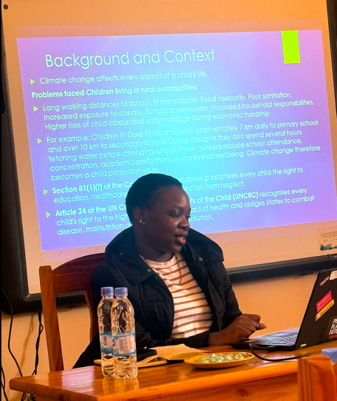
Participants welcomed the presentation for highlighting the important and emerging intersection between climate change and children’s rights, particularly in rural communities where children experience disproportionate impacts due to limited adaptive capacity and existing social vulnerabilities. The discussion recognised the strength of the presentation in moving beyond climate change as an environmental issue and positioning it as a child rights and protection concern affecting children’s access to education, health, nutrition, protection and overall wellbeing. Participants appreciated the focus on Dora Pindo, Mutare, as a context specific case study demonstrating how climate related challenges such as drought, water scarcity, food insecurity and changing weather patterns influence children’s daily lives and ability to realise their rights.

Discussion Points: A key area of discussion focused on refining the scope and geographical framing of the research. Participants noted that while the title refers broadly to “Climate Change and Child Rights in Rural Africa,” the study primarily focuses on Dora Pindo in Mutare, Zimbabwe. It was recommended that the title be narrowed to reflect the specific geographical context and avoid creating expectations of a broader continental analysis. Participants suggested that positioning the research around Dora Pindo, Mutare would strengthen the study’s contextual relevance and allow for deeper analysis of children’s lived experiences within a clearly defined setting.
Participants further recommended narrowing the conceptual scope of the study by identifying the specific children’s rights dimensions being examined. It was noted that climate change affects multiple aspects of children’s lives, including education, health, nutrition, protection and participation and attempting to address all these areas may make the research too broad. The author was encouraged to identify the primary rights focus of the study and establish clearer links between specific climate related challenges and their effects on selected child rights outcomes.
A significant discussion centred on strengthening the research objectives and methodological focus. Participants observed that terms such as “impact” may suggest a broader and more complex assessment than may be feasible within a small scale study. It was recommended that the author consider using terms such as “effects” or “influences” to better align with the scope and capacity of the research. Participants also advised reducing the number of objectives and focusing on approximately three key objectives to ensure that the study remains manageable while generating meaningful findings.
Participants highlighted that children’s participation in climate governance is a broad area of study that could constitute a separate research focus. While recognising its importance, participants encouraged the author to carefully consider whether this component can be sufficiently addressed within the current research scope or whether it should be narrowed to a specific aspect such as children’s awareness of climate policies, participation in local adaptation initiative or inclusion in community decision making processes.
Key Recommendations from session 3
- Promote people-centred, evidence informed research and policy development that places communities, particularly women and children at the centre of climate resilience and environmental governance. Participants emphasised the need for context specific research that captures lived experiences and informs gender responsive, child sensitive and community driven climate adaptation policies and programmes.
- Strengthen inclusive and participatory environmental governance by integrating the voices, knowledge and experiences of local communities, including children, into climate resilience planning, policy formulation and implementation. This includes recognising indigenous and community knowledge systems, fostering meaningful participation and promoting collaborative approaches that enhance environmental wellbeing and build resilient communities
_________________________________________________________________________
Session 4: Power, and the pursuit of agency in environmental governance ecosystems

Tsitsi Masengure: Strategic Litigation as a Tool. Examining the ZELA v ZimGOLD case to evaluate how public interest law and constitutional rights enforce environmental standards for child protection.
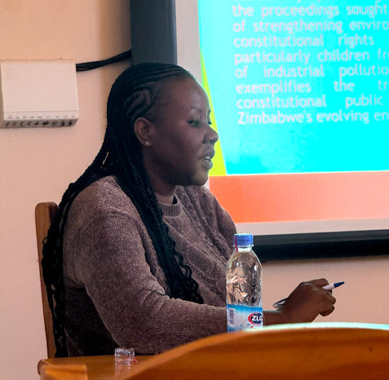
Participants welcomed the presentation for examining the important role of strategic litigation as a tool for advancing environmental justice, constitutional accountability and the protection of children’s environmental rights. The discussion recognised the paper’s contribution in demonstrating how public interest litigation can move environmental harm beyond a regulatory concern and frame it as a constitutional human rights issue. Participants commended the focus on the ZELA v ZimGOLD case as an important example for examining the relationship between constitutional rights, corporate responsibility, judicial intervention and environmental governance in Zimbabwe.
Discussion Points: A key area of discussion focused on assessing the long-term impact and effectiveness of strategic litigation beyond the courtroom outcome. Participants questioned whether the ZELA v ZimGOLD litigation had resulted in improved environmental protection practices or stronger accountability mechanisms in other mining contexts. It was noted that while strategic litigation has the potential to create legal precedents, clarify constitutional obligations and influence governance systems, its impact may be limited without effective enforcement, institutional commitment and follow up mechanisms. Participants recommended that the paper strengthen its analysis by examining the gap between judicial decisions and practical implementation including whether successful litigation translates into improved environmental outcomes for affected communities.
Participants further highlighted the importance of examining the post judgment trajectory of strategic litigation cases, particularly what happens after court decisions are issued and whether legal victories are sustained through subsequent judicial and administrative processes. The discussion raised questions around the progression of the ZELA v ZimGOLD matter through different court levels and whether movement between courts creates delays or weakens the intended impact of strategic litigation. Participants recommended that the author explore how procedural pathways, appeals and judicial interpretation influence the effectiveness of public interest litigation in advancing environmental justice.
It was further raised the need to critically examine the purpose and intended outcomes of strategic litigation before pursuing legal action. Participants cautioned that litigation should not be viewed only as an achievement or institutional milestone but should be assessed based on whether it generates meaningful change for affected communities. The recommendation was that organisations pursuing strategic litigation clearly define their intended outcomes from the outset, including whether the objective is policy reform, improved enforcement, corporate accountability, community protection, legal precedent or broader systemic change. The paper was encouraged to include a framework for evaluating the success of strategic litigation beyond court judgments.
Participants also recommended strengthening the analysis of the relationship between litigation and environmental governance institutions. While strategic litigation can address governance failures and compel action, participants noted that courts alone cannot resolve systemic environmental challenges. The author was encouraged to explore how litigation can work alongside stronger regulatory institutions, environmental monitoring mechanisms, administrative enforcement and community accountability systems. Greater attention should be given to the role of government agencies responsible for environmental protection and how institutional weaknesses affect the implementation of judicial decisions.
The discussion further highlighted the importance of examining children’s environmental rights within strategic litigation frameworks. Participants encouraged the author to strengthen the connection between environmental harm and specific child rights concerns, including children’s rights to health, education, protection and a safe environment. The paper was encouraged to explore how strategic litigation can centre children not only as beneficiaries of environmental protection but also as rights holders whose interests require proactive consideration in environmental decision making.
Recommended was also strengthening the paper’s examination of constitutional and legal frameworks supporting public interest litigation, particularly the role of constitutional provisions such as Section 85 on public interest standing and Section 73 on environmental rights. The author was encouraged to analyse how these provisions have expanded opportunities for communities and civil society actors to challenge environmental harm and hold corporate and state actors accountable.
Participants also encouraged the author to consider comparative experiences from other African jurisdictions where strategic litigation has contributed to environmental justice outcomes. Comparative examples were recommended to demonstrate how courts, communities, and civil society organisations have navigated the challenges of enforcement, compliance monitoring and institutional accountability following environmental litigation.
Overall, the discussion reinforced that strategic litigation is an important but not standalone pathway for advancing environmental justice. Participants emphasised that its transformative potential depends on effective implementation, institutional accountability, community engagement and alignment with broader governance reforms. The paper was recognised as making an important contribution by interrogating the role of courts in protecting children’s environmental rights and challenging environmental governance failures. Participants encouraged the author to strengthen the analysis by moving beyond the question of whether litigation succeeds in court towards examining whether it produces lasting systemic change for communities and future generations.
_________________________________________________________________________
Ashton Mufari: Climate Finance and Environmental Protection in Zimbabwe – A Legal and Institutional Analysis

Participants welcomed the presentation for examining the emerging and underexplored relationship between climate finance, environmental protection and legal governance frameworks in Zimbabwe. The discussion recognised the importance of positioning climate finance not merely as a financial mechanism but as a critical governance tool for enabling Zimbabwe to fulfil constitutional environmental obligations, implement climate commitments and strengthen environmental protection systems. Participants commended the presentation for contributing to an area of research that remains relatively limited within the Zimbabwean context and noted the potential value of the paper as a reference point for future scholarship, policy development and climate governance discussions.

Discussion Points: A key area of discussion focused on the need to strengthen engagement with the emerging Climate Change Management Bill in Zimbabwe and its implications for climate finance governance. Participants encouraged the author to analyse the extent to which the proposed legislation addresses climate finance mechanisms, institutional arrangements, accountability and access to climate resources. While recognising that the Bill introduces provisions related to climate governance and adaptation frameworks, participants noted the importance of examining whether it sufficiently addresses the domestication of international climate finance principles within Zimbabwe’s legal framework. The author was encouraged to consider how the Bill could strengthen national ownership, transparency and accountability in the mobilisation and utilisation of climate finance.
Participants also discussed the relationship between the author’s research and the evolving policy landscape, particularly concerns regarding whether new legislation may supersede or limit the relevance of the research. The discussion emphasised that emerging laws provide an opportunity to strengthen rather than diminish academic contributions, as research can provide critical analysis, identify implementation gaps and inform legislative improvements. Participants recommended that the paper position itself as a resource for evaluating and strengthening climate finance provisions within Zimbabwe’s evolving climate governance framework.
A significant area of discussion centred on the enforceability of international climate finance obligations and commitments. Participants questioned how international climate finance requirements can be enforced and what mechanisms exist to ensure compliance. The discussion highlighted that similar to many areas of international environmental law enforcement is often indirect and depends on institutional arrangements, funding conditions, reporting requirements and accountability mechanisms rather than traditional enforcement approaches. Participants recommended that the author strengthen the analysis by examining how international climate finance institutions, donor requirements and global climate agreements influence national climate finance governance and compliance.
Participants further encouraged the author to explore the domestic accountability dimensions of climate finance including the role of individuals, communities, institutions and private sector actors in contributing to climate action. The discussion highlighted the importance of considering how responsibility for environmental protection can be distributed beyond government institutions to include citizens, businesses, local authorities and communities. The author was encouraged to examine possible mechanisms for promoting individual and collective responsibility including awareness, participation, reporting and community based monitoring approaches.
Participants also recommended strengthening the analysis of institutional coordination and governance challenges affecting climate finance implementation in Zimbabwe. While climate finance provides important opportunities for supporting adaptation and mitigation efforts, participants noted that limited institutional capacity, fragmented mandates and weak coordination may constrain effective utilisation of available resources. The paper was encouraged to identify institutional gaps and propose mechanisms for improving coordination among government ministries, environmental authorities, financial institutions, development partners and community stakeholders.
The discussion further highlighted the need to examine how climate finance can better support environmental justice and vulnerable communities. Participants encouraged the author to explore whether climate finance mechanisms adequately respond to the needs of communities most affected by climate change, including women, children, rural communities and marginalised groups. The paper was encouraged to incorporate considerations of equity, participation, transparency and accessibility in climate finance governance.
Overall, participants recognised the presentation as making an important contribution to understanding climate finance as a critical component of environmental governance in Zimbabwe. The discussion reinforced the need for legal and institutional frameworks that ensure climate finance is transparent, accessible, accountable and aligned with constitutional environmental rights. Participants encouraged the author to further develop the paper by integrating analysis of emerging climate legislation, institutional accountability, international climate finance mechanisms and community level responsibility. The paper was acknowledged as a valuable foundation for advancing national conversations on how climate finance can support sustainable environmental protection and climate resilience in Zimbabwe.
_________________________________________________________________________
Magadaline Hamukwani & Marble Ncube: Reclaiming Knowledge, Reclaiming Power: Rethinking Natural Capital through Indigenous Women’s Ecologies in Nyanga Tombo, Zimbabwe
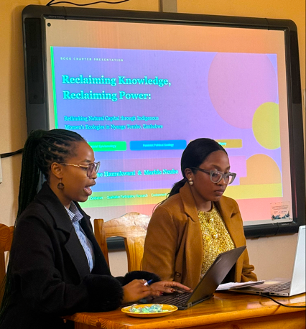
The presentation interrogated dominant environmental governance paradigms through a critical, feminist and decolonial lens focusing on how knowledge systems shape power relations in natural resource management. It situated Indigenous women in Nyanga Tombo, Zimbabwe as central actors in ecological stewardship whose contributions remain marginalized in mainstream frameworks.
The study is grounded in African Feminist Epistemology recognising situated, embodied and gendered knowledge systems and the Feminist Political Ecology (FPE) analysing power, gender and ecological access/control and the decolonial theory challenging Eurocentric knowledge hierarchies and reclaiming Indigenous ways of knowing. Methodologically, the research employs qualitative participatory approaches emphasizing lived experiences, community knowledge and co-production of insights.
Discussion Points: Discussions from peer reviewers stated that the study is unique in looking at the interlocking lenses and the symbiotic relationship between IKS and science, who counts as a knower and the undervaluing of IKS. The researchers were guided to briefly describe how nature communicates to humans and how do we look at nature’s rights and the need to change the way people look at nature. They were also recommended to add quotes on the richness of Africa in IKS and respect for nature.
Key recommendations from session 4
- Strengthen legal and institutional frameworks that enhance accountability, transparency and access to environmental justice. Participants emphasised the need to move beyond the existence of laws and court decisions towards ensuring effective implementation, enforcement and institutional accountability, including monitoring the long term impact of strategic litigation and climate governance interventions.
- Promote inclusive and participatory environmental governance by recognising communities, particularly women, children and Indigenous People as active rights holders and knowledge partners. Environmental governance systems should create meaningful opportunities for community participation, integrate indigenous knowledge systems alongside scientific knowledge and strengthen local ownership of environmental decision making.
- Strengthen policy coherence by integrating constitutional rights, climate finance mechanisms and environmental governance reforms. Participants recommended aligning emerging legislation, institutional arrangements and financing mechanisms with constitutional environmental rights and international commitments to ensure that climate finance and environmental policies are transparent, equitable and responsive to the needs of vulnerable communities.
- Advance interdisciplinary, decolonial and evidence-informed research that bridges law, policy, Indigenous Knowledge Systems and practice. Future research should generate practical solutions that inform policy reform, recognise the value of African knowledge systems draw on comparative experiences where appropriate, and contribute to transformative environmental governance that centres justice, resilience and sustainability
______________________________________________________________________
Session 4 Empowered systems for Environmental Governance
Babongile T.A. Mhlanga: Adolescents as Climate Rights-Holders: Assessing the Recognition and Protection of Adolescent SRHR within Zimbabwe’s Climate Governance Framework – Virtually presented
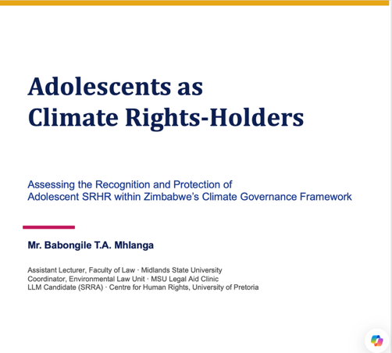
Participants welcomed the presentation for introducing a timely and innovative examination of the intersection between climate change, adolescence and sexual and reproductive health and rights (SRHR) within Zimbabwe’s climate governance framework. The discussion commended the paper for adopting a strong intersectional approach that moves beyond traditional policy silos by demonstrating how climate stress, adolescent development and SRHR interact to create unique vulnerabilities that are often overlooked in law and policy. Participants recognised the paper as an important contribution to emerging debates on climate justice by positioning adolescents as distinct rights holders whose needs require specific legal and policy recognition.
Discussion Points: A key area of discussion centred on the justification for focusing specifically on adolescents rather than children more broadly. Participants acknowledged the author's explanation that adolescents occupy a unique developmental stage characterised by evolving capacities, increasing autonomy and distinct sexual and reproductive health needs that are often inadequately addressed when they are grouped either with younger children or with adults. It was recognised that adolescents frequently remain invisible within legislative and policy frameworks despite facing challenges such as access to SRHR information and services, menstrual health management, adolescent pregnancy, child marriage and gender-based violence. Participants encouraged the author to strengthen this conceptual distinction throughout the paper by clearly demonstrating why adolescents require specific legal recognition and targeted protections within climate governance frameworks.
The author was further encouraged to strengthen the paper's analysis by examining the extent to which Zimbabwe's climate governance instruments explicitly recognise adolescents as a distinct category of rights holders. The discussion highlighted that many existing legal and policy instruments refer generally to children, women or vulnerable groups without acknowledging the specific rights, capacities and vulnerabilities associated with adolescence. It was recommended that the paper further analyse whether current governance frameworks provide substantive rights, procedural rights and protection measures that specifically respond to adolescent’s experiences within climate related contexts.
A significant discussion focused on the absence of dedicated regional or international legal frameworks addressing adolescent SRHR within climate governance. Participants observed that while international and regional human rights instruments refer to adolescents in different contexts, there is currently no comprehensive model law specifically integrating adolescent SRHR within climate governance. The author was encouraged to position the paper as contributing to this emerging area of scholarship by identifying legal and policy gaps and proposing principles that could inform future national, regional or international normative frameworks.
Participants also highlighted the importance of mainstreaming adolescent considerations across climate governance instruments rather than treating adolescent rights as a peripheral issue. The discussion recommended that climate policies, legislation, adaptation strategies, disaster risk management frameworks and implementation mechanisms should consistently recognise adolescents as distinct rights holders. Participants emphasised that such recognition should go beyond symbolic references and include enforceable rights, meaningful participation opportunities and clear responsibilities for duty bearers to protect adolescent SRHR within climate related responses.
A reflective discussion explored whether it would be feasible to develop a single integrated legal instrument addressing climate change, adolescent rights and SRHR or whether mainstreaming adolescent issues across existing legal and policy frameworks would provide a more practical and effective approach. Participants encouraged the author to critically engage with this question by examining the advantages and limitations of both approaches while considering Zimbabwe's existing legislative landscape and institutional arrangements.
Participants further recommended strengthening the paper's discussion on participation and procedural rights by examining how adolescents can be meaningfully involved in climate governance and decision-making processes. The author was encouraged to explore mechanisms that ensure adolescents are recognised not only as beneficiaries of climate action but also as active participants whose perspectives can inform climate adaptation, resilience planning and policy development.
Overall, the discussion reinforced the importance of recognising adolescents as distinct climate rights holders whose sexual and reproductive health and rights are increasingly shaped by climate change. Participants commended the paper for addressing an underexplored area of environmental governance and encouraged the author to strengthen its legal analysis by clarifying the distinct status of adolescents, proposing practical mechanisms for mainstreaming adolescent rights within climate governance and contributing to the development of more inclusive and responsive legal and policy frameworks. The paper was recognised as making a significant contribution to advancing intersectional, rights-based and adolescent centred approaches to climate governance in Zimbabwe and beyond.
___________________________________________________________________________
Rumbidzai Madzivadondo: Participation of women in water governance
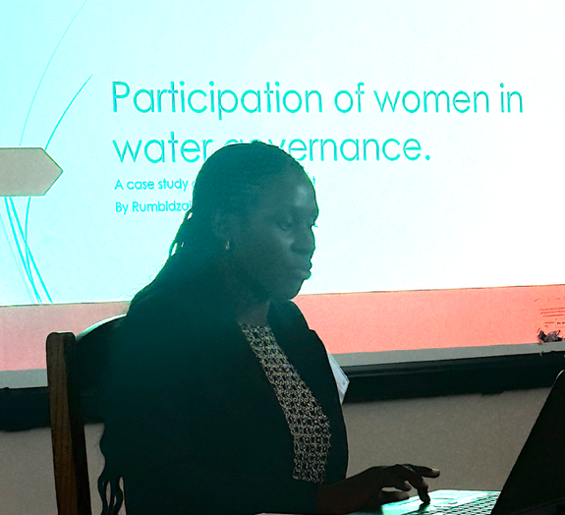
Participants welcomed the presentation for addressing the important issue of women’s participation in water governance within the context of climate change and increasing water insecurity. The discussion recognised the paper’s relevance in highlighting the disconnect between women’s central role in household and community water management and their limited representation within formal water governance structures. Participants commended the study for focusing on Zvimba District as a case study and acknowledged its potential to contribute practical recommendations for strengthening gender responsive water governance in Zimbabwe.
Discussion Points: A key area of discussion centred on identifying the structural patterns that influence women’s participation in water governance. Participants encouraged the author to strengthen the analysis by drawing out common themes emerging from the different communities studied rather than presenting individual experiences in isolation. It was observed that leadership positions within local water governance structures are predominantly occupied by men, despite women being the primary users and managers of water resources. The author was encouraged to examine how cultural norms, gender roles, institutional practices and power dynamics collectively shape women’s participation across communities and influence access to leadership and decision making opportunities.
Participants further encouraged the author to critically reflect on the authenticity and depth of participant’s responses, particularly whether some responses may have been influenced by social expectations or a desire to provide acceptable answers. The discussion highlighted the importance of interrogating whether women felt sufficiently comfortable to openly discuss barriers to participation or whether underlying power relations affected the information shared during interviews. Participants recommended that the paper consider these methodological reflections when interpreting the findings and discussing women's lived experiences.
A significant discussion focused on the extent to which women understand their roles and responsibilities within local water governance committees. Participants questioned whether women serving on these committees have adequate knowledge, capacity and institutional support to effectively contribute to decision making or whether their participation is largely symbolic. The author was encouraged to explore not only the numerical representation of women but also the quality of their participation, including their influence over decisions, confidence to contribute, access to information and opportunities for leadership within governance structures.
Participants also highlighted intimidation and unequal power relations as important barriers to women's effective participation in water governance. The discussion recognised that these challenges are not unique to rural communities but are also evident within urban governance spaces. Participants recommended that the paper further examine how intimidation, social norms, patriarchal attitudes and unequal power dynamics affect women's confidence, voice and ability to influence water governance decisions. The author was encouraged to identify practical strategies for creating governance environments that are safe, inclusive and supportive of women's meaningful participation.
Participants further recommended strengthening the paper by distinguishing between formal representation and substantive participation. It was noted that increasing the number of women serving on water governance committees does not necessarily translate into meaningful influence over governance processes. The author was encouraged to assess whether women are actively involved in agenda setting, decision making and implementation and to identify institutional and community level reforms that can move participation beyond symbolic inclusion towards genuine leadership and shared decision making.
The discussion also encouraged the author to develop practical recommendations for strengthening women's leadership and capacity within water governance systems. Participants suggested that the paper identify interventions such as leadership development, awareness raising on governance roles, institutional reforms, gender sensitive policies and community engagement strategies that could improve women's participation while addressing structural barriers that limit their involvement.
Overall, the discussion reinforced the importance of recognising women as central actors in sustainable water governance rather than simply primary users of water resources. Participants encouraged the author to strengthen the paper by deepening the analysis of structural barriers, power relations and the quality of women's participation while proposing actionable legal, institutional and community based reforms that promote meaningful, equitable and gender-responsive water governance. The paper was recognised as making an important contribution to advancing inclusive environmental governance by demonstrating that sustainable water management requires women's voices, leadership and decision making authority to be fully recognised and supported.
___________________________________________________________________________
Key Recommendations from session 4
- Strengthen inclusive environmental governance frameworks by explicitly recognising women, adolescents and other marginalised groups as distinct rights holders with meaningful roles in environmental decision making. Participants emphasised that governance systems should move beyond symbolic inclusion to ensure substantive participation, leadership and representation in environmental and climate governance processes.
- Promote legal and policy reforms that mainstream gender, adolescent rights and community participation across environmental governance frameworks. Future legal and policy instruments should integrate these perspectives throughout climate, water and environmental governance systems to improve accountability, responsiveness and equitable access to environmental justice.
- Invest in institutional capacity building and community empowerment to strengthen meaningful participation in environmental governance. This includes leadership development, awareness raising, civic education and creating enabling environments that address structural barriers, unequal power relations and social norms limiting the participation of women and adolescents in governance processes.
- Advance evidence-informed and intersectional research that generates practical recommendations for strengthening environmental governance. Participants underscored the importance of research that examines the quality of participation, interrogates institutional and social barriers, and informs legal, policy and governance reforms that are responsive to diverse community experiences and environmental challenges.
Editorial Guidance Shared by Professor Stewart to Authors
Drawing on her experience as an editor and published academic, Proffesor Stewart provided practical guidance to support authors in strengthening their draft chapters for publication. Her advice focused on improving clarity, coherence, analytical depth and ensuring that each chapter communicates its core argument effectively to readers.
Participants were encouraged to revisit their presentation slides, viewing them as distilled summaries of their research. Proffesor Stewart noted that the presentations often captured the central arguments more clearly than the draft papers and advised authors to use them as a starting point for refining their chapters. Authors were encouraged to revisit the key frameworks, themes and messages that emerged during their presentations and workshop discussions, pruning away unnecessary detail to ensure that each chapter remains focused on its essential contribution.
She further encouraged authors to clarify the purpose and nature of their chapters, distinguishing whether they are writing a descriptive scholarly chapter or a textbook. This distinction is important because each requires a different writing approach and level of methodological detail. Where a chapter adopts a more instructional or textbook style, the methodology and analytical processes should be explained more comprehensively.
Professor Stewart also shared guidance on structuring chapters in a logical and reader friendly manner. She recommended beginning with an introduction that sets the scene, locating the reader within the geographical, historical, legal or conceptual context of the study. Rather than assuming prior knowledge, authors should gradually introduce the reader to the issues under discussion and provide sufficient context to understand the significance of the research.
She advised authors to use "Problem Description" instead of "Problem Statement", as this allows for a richer explanation of the issue being investigated and why it matters. This should be followed by a clear explanation of what needed to be done to address the problem, including the methodological approach adopted by the research. The paper should then progress logically through the research findings, supported by fieldwork or other sources of evidence, followed by a robust analysis that interprets the findings rather than merely describing them. Instead of ending with a conventional conclusion, Professor Stewart recommended including a discussion section that reflects on how the research findings have shaped new insights, challenged existing thinking or contributed to broader debates. Authors were encouraged to demonstrate how their research advances understanding of the topic and its implications for law, policy or practice.
A central message throughout her guidance was that good academic writing should guide the reader through the research journey. Authors were encouraged to write with the assumption that readers are intelligent but unfamiliar with the subject matter carefully leading them through the context, evidence, analysis and arguments in a logical and engaging manner.
Finally, Professor Stewart advised that referencing requirements and the preferred citation style for the edited volume would be discussed and circulated to all authors to ensure consistency across the publication

Closing Remarks and Way Foward
In her closing remarks, Dr. Mukumbiri expressed appreciation to all participants for their active engagement and the high quality of scholarly discussions throughout the workshop. She noted that the convening aligns closely with the University's Strategic Plan and Education 5.0 agenda, which emphasise the production of impactful, evidence based research that contributes to solving real world challenges. She highlighted that one of the most encouraging outcomes of the workshop was the strong potential for the research presented to influence policy, legislation and environmental governance practice.
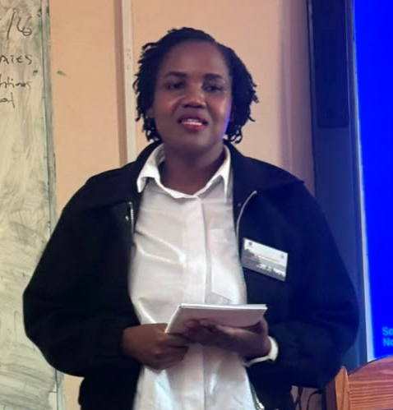
Dr. Mukumbiri extended her sincere gratitude to all presenters, including those who participated physically, virtually and those whose contributions were shared despite being unable to attend in person. She also acknowledged the dedication of the organising team and editorial leadership specifically recognising Professor Stewart, Dr. Katsande and Danai for their commitment to supporting the development of the edited volume and creating a collaborative space for scholarly engagement.
Encouraging the authors, Dr. Mukumbiri reminded participants that every research idea has value and urged them to have confidence in the significance of their work. She emphasised that each contribution has the potential to advance knowledge, shape policy debates and strengthen environmental governance from feminist, child rights and rights of nature perspectives.
Reflecting on the anticipated publication, she expressed confidence that the edited volume would become an important scholarly resource particularly within Zimbabwe where there is currently limited literature bringing together environmental governance, women's rights, children's rights and the rights of nature from an African perspective. She noted that the publication has the potential to serve as a valuable reference for students, researchers, policymakers and practitioners while contributing to the growth of locally generated knowledge in this field.
Dr. Mukumbiri further expressed optimism that the workshop would mark the beginning of sustained collaboration among the authors and partner institutions. She encouraged participants to maintain the enthusiasm, relationships and momentum generated during the workshop expressing hope that this initiative would lead to many future collaborative research projects, publications and policy engagement opportunities.
Outlining the way forward, Dr. Mukumbiri reminded all contributors that revised draft chapters are to be submitted by 31st August 2026, including authors who were unable to present during the workshop. She explained that all submissions would undergo a peer review and editorial feedback process to strengthen the quality and consistency of the chapters before publication. Looking ahead, she also shared the aspiration of hosting an official book launch which would provide an opportunity to showcase the completed volume, celebrate the author’s contributions and further engage stakeholders on advancing rights based environmental governance through research, policy and advocacy.

The End

Annex 1 Workshop Programme

“RECLAIMING EARTH, RECLAIMING POWER: DIALOGUES ON WOMEN, CHILDREN, AND NATURE’S RIGHTS IN ENVIRONMENTAL GOVERNANCE.”
23 - 24 July 2026
University of Zimbabwe Faculty of Law, Southern and Eastern African Regional Center for and Women and Children’s Rights (SEARCWL)
Venue: Women’s Law Center, UZ, Harare, Zimbabwe
(Timezone: CAT)

Workshop Objectives
The main objective of this convening is to provide a participatory and dialogical space for collective engagement, peer learning, and the development of selected papers into chapters for the forthcoming edited volume; “Reclaiming Earth, Reclaiming Power: Dialogues on Women, Children, and Nature’s Rights in Environmental Governance.”
- Obtain peer and stakeholder feedback on the draft papers developed by the selected authors to strengthen their quality, relevance, and policy applicability.
- Facilitate feminist dialogue on the interconnections between women's rights, children's rights, and the rights of nature in environmental governance, drawing on diverse experiences and expertise.
- Generate recommendations for advancing gender-responsive, child-sensitive, and rights-based environmental governance through research, policy, and advocacy.

Expected Outputs
- Peer-reviewed and stakeholder-informed draft papers incorporating feedback and recommendations from the workshop discussions.
- A compilation of key recommendations on integrating feminist perspectives and the rights of women, children, and nature into environmental governance frameworks.
- A strengthened community of practice comprising researchers, practitioners, policymakers, and civil society actors committed to collaborative learning and advocacy.

Expected Outcomes
- Improved quality, credibility, and policy relevance of the draft papers, positioning them for publication and wider dissemination.
- Enhanced knowledge and shared understanding among participants of feminist approaches to environmental governance and the interconnected rights of women, children, and nature.
- Strengthened partnerships and sustained collaboration among authors, stakeholders, and institutions to promote evidence-informed advocacy and inclusive environmental governance. Proposed Agenda

Day 1

Time | Session | Lead
8:00–8:30 AM | Arrival and Check-in/Registration | All
8:30–8:35 AM | Introduction and Welcome Remarks | Dr. Katsande
8:35–9:40 AM | Objectives of the Workshop | Dr. Mukumbiri
9:40–9:50 AM | Official Workshop Opening | Office of the Dean  (Faculty of Law)
9:50-10:05AM | Keynote address | Professor Julie  Stewart
10:05–10:15 AM | Participant Introductions | All
10:15–10:30 AM | Tea Break
Author Presentations

30 minutes per author
15 minutes for presentation & 15 minutes for feedback
10:30 AM – 1:00  PM | Session 1: Access to Justice, The Environment, Women,  Children and the Law  Muchadzireva Burukai: Bridging the Gap: Women’s and Girls’ Access to Environmental Justice in Rural Zimbabwe 10:30 - 11:00 AM  Memory Makuyana: From Norms to Reality: Structural Barriers to Women’s Access to Environmental Justice under the Maputo Protocol and AU CEVAWG Frameworks 11:00 - 11:30 AM  Chingasiyeni Govhati: Legal Pluralism, Intergenerational Equity and Climate Justice in Africa: Children as Invisible Victims of Rural Climate Governance OR Chingaiseyi Govhati: Beyond Presence: Digitalisation and Substantive Participation of Women in Environmental Governance in Southern Africa 11:30 AM - 12:00 PM  Ashton Mufari: Climate Finance and Environmental Protection in Zimbabwe – A Legal and Institutional Analysis OR Ashton Mufari: Reimagining Zimbabwean Environmental Law and Governance Through Decolonial Lenses 12:00 - 12:30 PM  Tsitsi Masengure: Integrating Children’s rights into the new climate laws: The proposed Climate Change Management Bill, as an opportunity to incorporate international child rights standards into its frameworks on carbon trading and emissions. 12:30 - 1:00 PM | Memory  Chadambuka
1:00– 2:00 PM | Lunch Break

2:00 - 4:30 PM | Session 2: Theories for Change in Environmental Justice  Jacqueline Nechavava: Entangled Vulnerabilities: An African Feminist Critique of Environmental Governance: Bridging Women’s, Children’s and Nature’s Rights in Zimbabwe 2:00- 2:30 PM  Tendai Mupudzi: Extractive Dust and Intergenerational Environmental Injustice: An African Feminist Critique of Lithium Mining Governance in Zimbabwe  2:30-3:00 PM  Charlotte Chikoore: Environmental degradation in Mutasa District, Manicaland, Zimbabwe as a result of alluvial mining, the legal interventions, their potential implications and the role of women in the rehabilitation process: Statutory Instrument 188 of 2024 3:00 - 3:30 PM  Talent Viviane Fetso: Reimagining Environmental, Social, Governance through an African lens: A deep dive into Women’s Rights, Corporate Accountability, and ESG in Zimbabwe 3:30 - 4:00  Shimtah Nembaware Women in grey zone of resource governance: Examining Gender Access Control and Benefit Sharing in Ward 17 Chimanimani Zimbabwe 4:00 - 4:30 PM | Tsitsi Masengure
 | Tea & End of day 1

Day 2
Time | Session | Lead
8:30 - 10:00 PM | Session 3: Resilience: Centering People,  Community and Environmental Wellbeing  Tadiwanashe Burukai-Matutu: From Survival to Power: Feminist Community Responses to Environmental Injustice in Mining Communities in Zimbabwe  8:30 - 9:00AM  Chido Nyaruwata: Waste Harvesters of Harare: Feminist Political Ecology and the Labour of Urban Waste  9:00 - 9:30 AM  Jane Jambaya: Reclaimed Imagination Studio: Children’s Art as Environmental Jurisprudence - Centering Grief, Play and Nature’s Rights in Zimbabwe’s Peri Urban Margins  9:30 AM - 10:00 AM | Magadaline Hamukwani
10:00 - 10:15 AM | Tea Break
11:15 - 1:00 PM | Session 4: Empowered systems for Environmental Governance  Mika (Jaeyun) Noh: Algorithmic Extraction and Ecological Memory: AI Governance, Cultural Sovereignty, and Feminist Environmental Futures  11:15 - 11:45 AM  Babongile T.A. Mhlanga:Adolescents as Climate Rights-Holders: Assessing the Recognition and Protection of Adolescent SRHR within Zimbabwe’s Climate  Governance Framework  11:45 AM - 12:15PM  Rumbidzai Madzivadondo: Participation of women in water governance  12:15 PM - 12:45 PM | Magadaline Hamunakwani
1:00 - 2:00 PM | Lunch Break
2:00 - 4:30 PM | Indigenous Women’s Ecologies in Honde Valley, Zimbabwe.  2:30 - 3:00 PM  Rachael Goba: Who Speaks for the Earth? Feminist Reflections on Inclusion, Power, and Environmental Governance  3:00 - 3:30 AM  Tea & End of Day Two and Workshop | Dr. Mukumbiri

